Pierre-Yves Vasener
pvasener@aup.edu
Abstract
This user’s guide presents how to use to Course Syllabus online tools to various university constituencies.
Course Syllabus
User’s guide

Revision History

Version | Date | Editor | Comments
1.0 | 2018/07/11 | Pierre-Yves Vasener | Initial Revision
1.1 | 2018/07/13 | Pierre-Yves Vasener | Claudia Roda Additions

Table of contents
1. Course Syllabus Visualization 4
1.1. Via the online Course Catalog 4
1.2. Via a Faculty Profile 6
2. Course Syllabus Edition 7
2.1. Create a new syllabus 7
2.2. Edit an existing syllabus 7
3. Administration 8
3.1. Learning Outcomes Edition 8
3.2. Syllabus Extra Fields 9
3.3. PDF Archives 10
3.3.1. Manually add a PDF archive 10
3.3.2. Auto-archiving 10
3.4. Completion Report 12
3.5. Notifications 13
3.5.1. Course Syllabus Edition 13
3.5.2. Faculty Reminder 13
3.6. Settings 14

Introduction and Vocabulary
This guide describes how course syllabi can be created, edited, visualized and archived through the course syllabi software.

Course Master and Course Offering
For the sake of this guide, courses are described at two levels: course master and course offering. A course master is the general version of the course, e.g. CS1040 Introduction to Computer Programming as approved by Curriculum Committee. A course offering is an instance of a course master, for example it may be CS1040 Introduction to Computer Programming offered in Fall 2018, taught by a given professor, at a given time in a given place.
The course syllabi software allows users to create, edit, visualize and archive syllabi for course offerings, however some properties - namely course name, number and learning outcomes - are associated to the course master. This means that every course offering associated to a course master may have a different syllabus but the curse name, number and learning outcomes will remain the same.
Note that textbooks are special cases. They are entered by faculty through the form made available by Academic Affairs early in the semester before the course will run. This information is automatically reported in the syllabus (the section is pre-filled with the information provided through the form).

Roles (who can do what)
The following table summarizes the functionalities available through the course syllabi software and the people who have access to the functionality.
 | Anyone with an AUP login | Faculty | Course Syllabus Editor (Designated persons in AA) | System Administrator (ITS)
Visualize syllabi Via the online Course Catalog | ✓ | ✓ | ✓ | ✓
Visualize syllabi Via the Faculty Profile |  | ✓ |  | ✓
Create the syllabus for a course |  | ✓ | ✓ | ✓
Edit the syllabus for a course |  | ✓ | ✓ | ✓
Create / Edit course Learning Outcomes |  |  | ✓ | ✓
Create / Edit course name, number or other CAMS retrieved fields (e.g. room and period) |  |  | ✓ | ✓
Add a new field (section) to the syllabi |  |  |  | ✓
Manually add a PDF syllabus (for archival purposes) |  |  | ✓ | ✓
Manage auto archiving |  |  | ✓ | ✓
Manage and access completion report |  |  | ✓ | ✓
Manage course syllabi software settings |  |  | ✓ | ✓

Faculty Sections
Please note that only sections 1, 2 and 3 are relevant for faculty. More information for faculty is available in the Frequently Asked Question file online at https://my.aup.edu/user/me/faculty/courses/syllabus-faq

Course Syllabus Visualization

Via the online Course Catalog
The Course Catalog is available on the public website under ‘Academics / Undergraduate / Course Catalog’ or directly at https://my.aup.edu/academics/course-catalog.
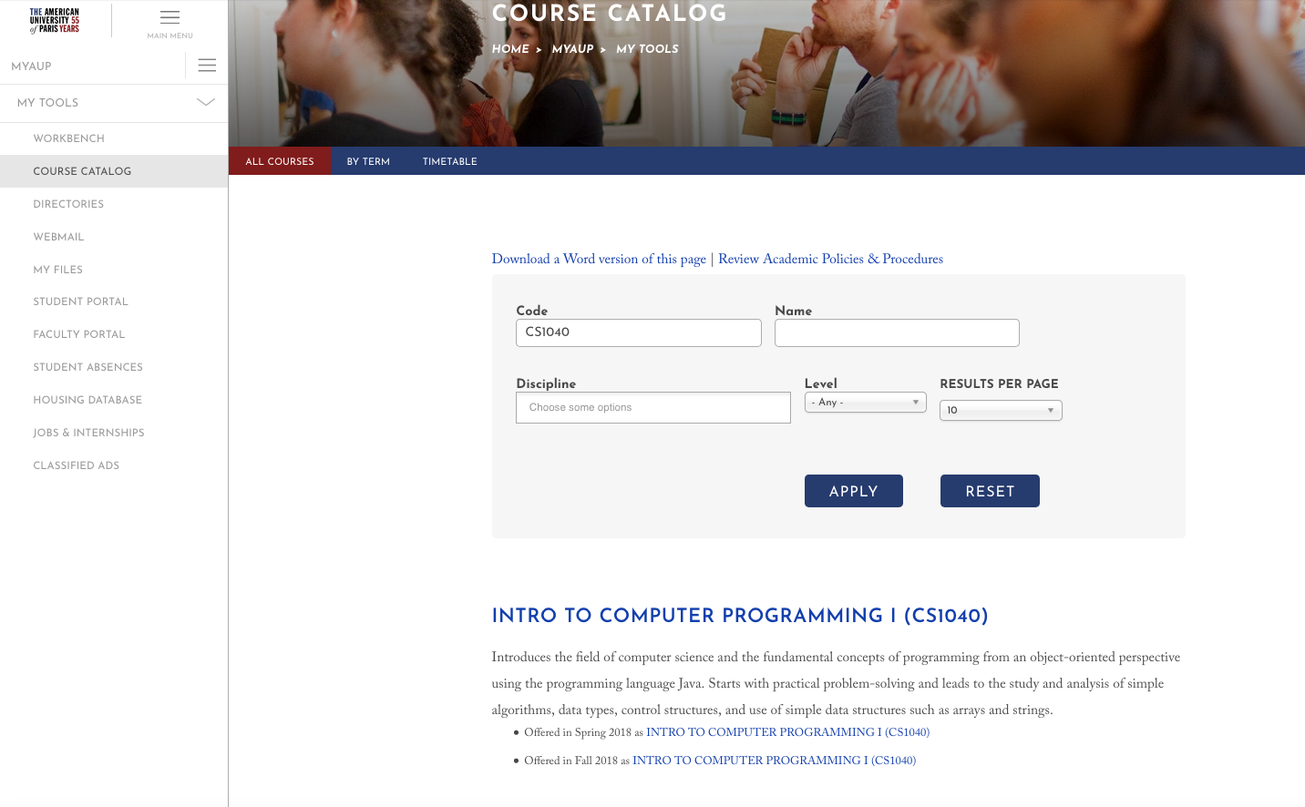
COURSE MASTER
COURSE OFFERINGS

On a course master page, visitors do not have access to the course syllabi but are invited to log in to access them:
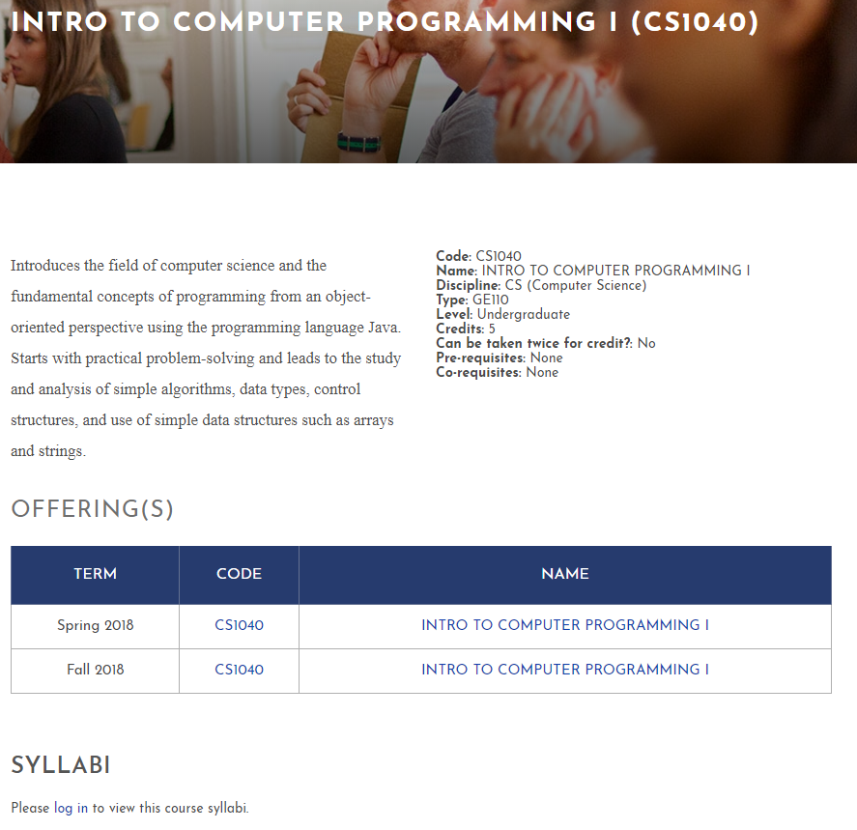
Once logged in, the current syllabus and PDF archives (if available) are accessible. So, instead of seeing “Please log in to view this course syllabi” you will be able to access the syllabi for the current or coming semesters as well as all the archived syllabi:
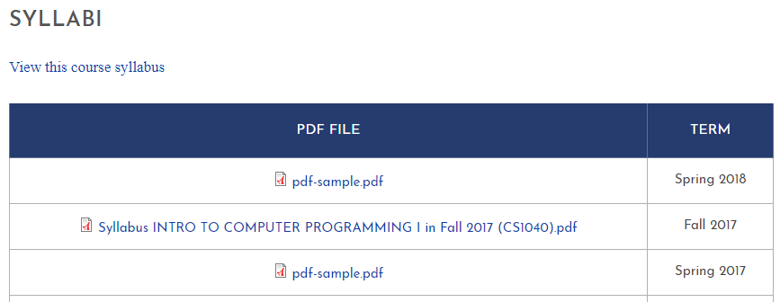
On a course offering page, the syllabus (online or PDF) is also accessible if available.

Via a Faculty Profile
A faculty member can access his/her syllabi via his/her profile on MyAUP at ‘MyAUP / My Profile / Faculty / My Courses’ or directly at https://my.aup.edu/user/me/faculty/courses.

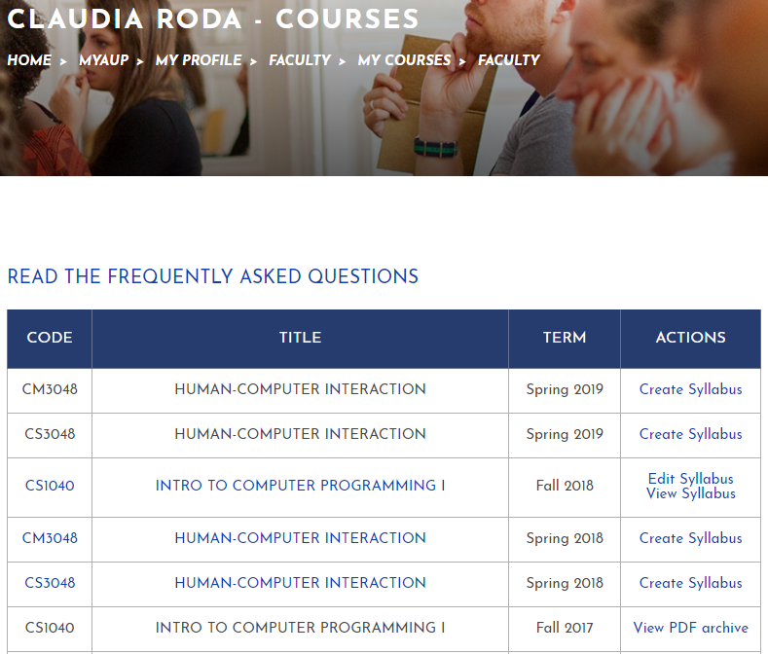
For each course offering a variety of actions are available:
- Create syllabus: If no syllabus exists for this offering.
- Edit & View Syllabus: If a syllabus exists for this offering.
- View PDF Archive: If an archived PDF exists for this offering.

Notes:
- Some courses don’t have syllabi (Labs, interships…)
- Any user having the ‘Course syllabus Editor’ role (Academic Affairs Team) can also access any faculty course list via profiles under the ‘Faculty / Courses’.

Course Syllabus Edition

Create a new syllabus
A faculty member can create a new syllabus either from a blank form or from cloning from one of his/her existing syllabi via the ‘Create Syllabus’ link:
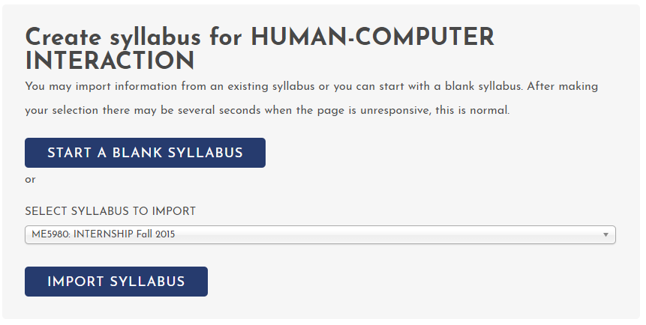
Notes:
- Academic Affairs can also create syllabi via the faculty profiles.
- All sections are optional.
- The Learning Outcomes and Textbooks sections can’t be edited as information come from CAMS.
- The syllabus is in draft (thus only visible to the faculty member and Academic Affairs) until the ‘Set syllabus as visible to AUP community’ option at the bottom of the form is checked.
- A preview of the Syllabus is available before submitting it via the ‘Preview’ button.
- The ‘Clear Fields’ button wipes all fields content.

Edit an existing syllabus
A faculty member can edit an existing syllabus until a PDF archive is created via the ‘Edit Syllabus’ link.
Notes:
- Academic Affairs can also edit syllabi via the faculty profiles.

Course Syllabus Edition Notification
When a syllabus is updated, an e-mail is sent to the faculty and syllabus@aup.edu. The status of the syllabus (Draft or final) is indicated in the body of the e-mail. The syllabus is visible to the AUP community only once the ‘Set syllabus as visible to AUP community’ option at the bottom of the form is checked.
See also 4.5 ‘Notifications’ section for a description of reminders sent to faculty and Academic Affairs.

Administration

Learning Outcomes Edition
Learning outcomes are stored at the Course Master level. Users with the ‘Course Syllabus Editor’ role can edit them via the ‘Edit’ tab:
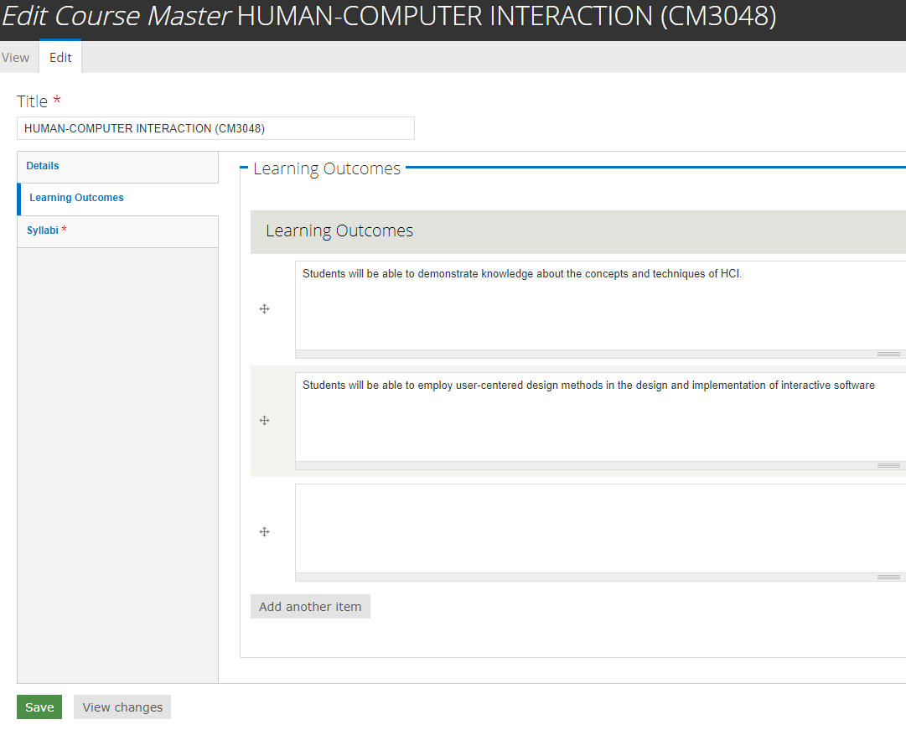
Notes:
- You can add a new outcome via the ‘Add another item’ button.
- To delete an outcome, simply wipe the field and leave it blank.
- You can re-order the outcomes by dragging and dropping the arrow icon at the left of each outcome.

Syllabus Extra Fields
Extra fields can be added to syllabi in the ‘Custom’ section via the Administration Menu (Structure / Content Types / Syllabus / Manage Fields):
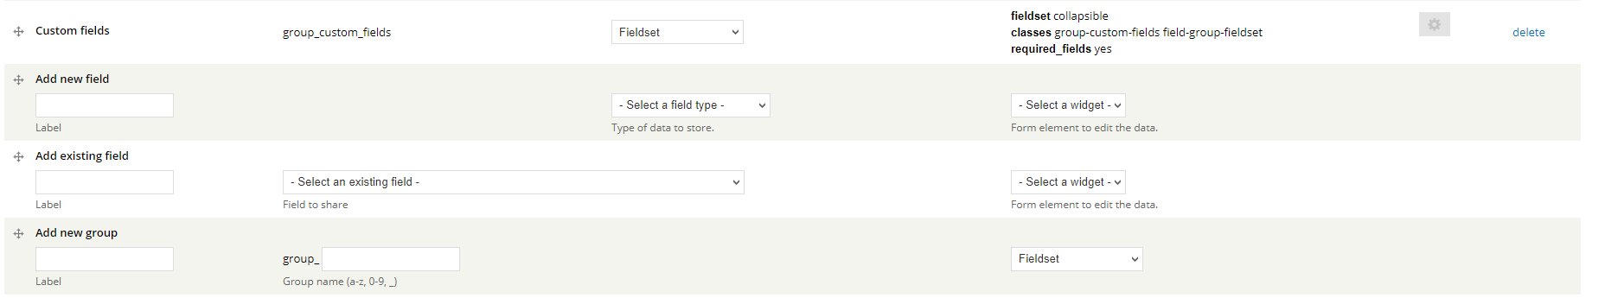
Notes:
- This feature is restricted to users having the ‘Site Administrator’ role, please contact the ITS Helpdesk (helpdesk@aup.edu) for any request about extra fields.

PDF Archives

Manually add a PDF archive
Syllabi PDF archives are stored at the Course Master level. Users with the ‘Course Syllabus Editor’ role can edit them via the ‘Edit’ tab: 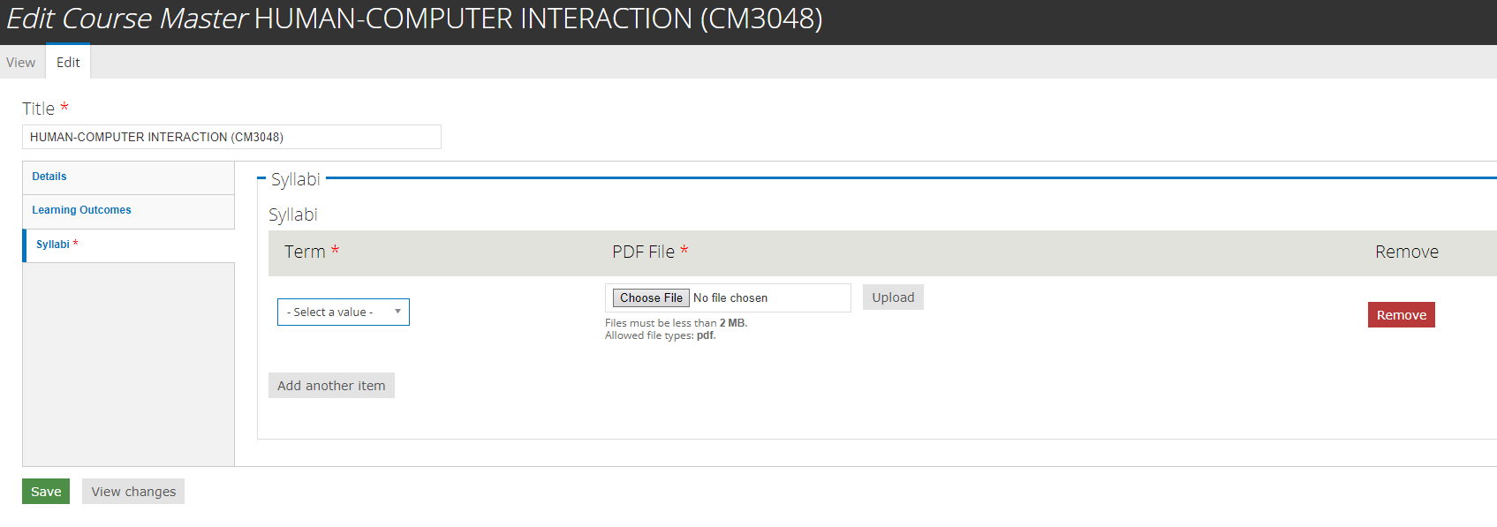
Notes:
- You can add a new PDF archive via the ‘Add another item’ button. Simply select the term in the dropdown list and upload the PDF using the ‘Choose File’ button.
- To delete an archive use the ‘Remove’ button. Be careful, deletions are permanent.
- You can re-order the PDF archives drag and dropping the arrow icon at the left of each outcome but it’s useless since an automatic re-ordering is performed when the course master is saved.

Auto-archiving
The archival day set up in the module settings (See 3.6), the syllabi of the previous semester are archived into PDF and added to the archive list on the Course Master pages. A report email is sent to administrators:
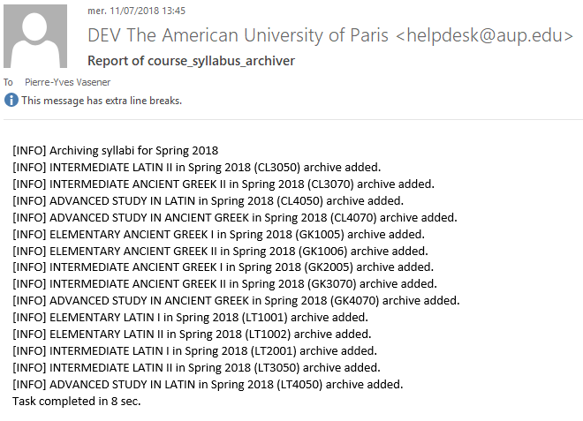
Note: To make sure the proper Learning Outcomes are present in the PDF archives, the modification of the Learning Outcomes for the next semester shouldn’t be done until the previous semester syllabi as archived as PDF.

Completion Report
A report about the status of course syllabi for the current semester is available at ‘My AUP / My Reports / Course Syllabi’. An Excel export is available via the CSV orange icon. The status of each syllabus is either:
- No: When no syllabus is created
- Yes: When a syllabus is present and published
- Draft: When a syllabus is present but not yet published

Notifications

Course Syllabus Edition
When a syllabus is updated, an e-mail is sent to the faculty and syllabus@aup.edu. The status of the syllabus (Draft or final) is indicated in the body of the e-mail.

Faculty Reminder
A certain number of days before the first day of classes, an e-mail is sent to all faculty members having missing or draft syllabi to invite them to finish their edition. Here is a sample:
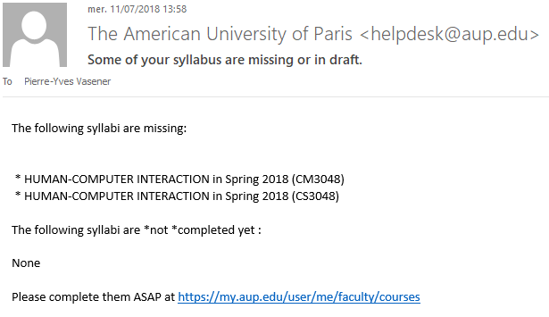
A report e-mail is also sent to the administrators:
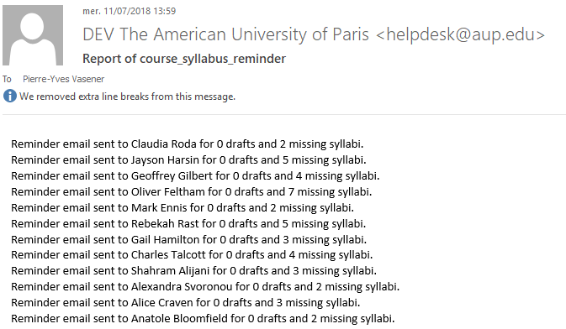

Settings
The module settings are available via the top administrator menu in ‘Configuration / AUP / Course Syllabus’. The following settings are available:
- First day of classes: Used to trigger the PDF auto-archiving feature as well as determining the current semester for the various actions of the module
- Archival Date: The finalized syllabi of the previous term will be archived as PDF at that date.
- Reminder Period: All professors who have not submitted a syllabus before the reminder period will receive the email below (e.g., if you select 20, all faculty who haven’t submitted their syllabi 20 days before the First day of classes will receive the email below). The default value for this field is 14. Note that multiple reminders may be sent by resetting the Reminder period. For example, if you set the reminder at 14 and after the day of the reminder (e.g., 13 days before the beginning of classes) you reset it at 7, then another reminder will be sent to those professors who have outstanding syllabi submissions 7 days before the beginning of classes.
- Mail Template: This is the body of the reminder e-mail sent to Faculty Members. The :missing: and :draft: placeholders are replaced with appropriate list of courses.
- Report email for the reminder email batch: List of e-mails who will receive the Reminder e-mail report. Each email is separated by a comma.
- Report email for the PDF archiver task: List of e-mails who will receive the PDF auto-archiver e-mail report. Each email is separated by a comma.

