GUIDE TO STUDENT PORTAL (student billing information)
This document provides students with a step-by-step guide to accessing their student billing ledger found in the student portal. It walks the student through the process of accessing and logging into their student portal, reviewing tuition and fees, application of loan funds, pending financial aid, and pending housing charges. The guide takes the student through the process of making an online payment in detailed steps and provides the information necessary to make a payment via bank transfer or check.

Table of Contents:
Accessing Student Portal .............................................................................................................................2
Problems with Login ….................................................................................................................................4
Accessing and Understanding Student Billing Ledger …..............................................................................5
How to Make a Payment …..........................................................................................................................8

Prepared by: SAS Office on August 11, 2023
GUIDE TO STUDENT PORTAL (student billing information)
- Go to my.aup.edu
- Select MY RESOURCES on left column
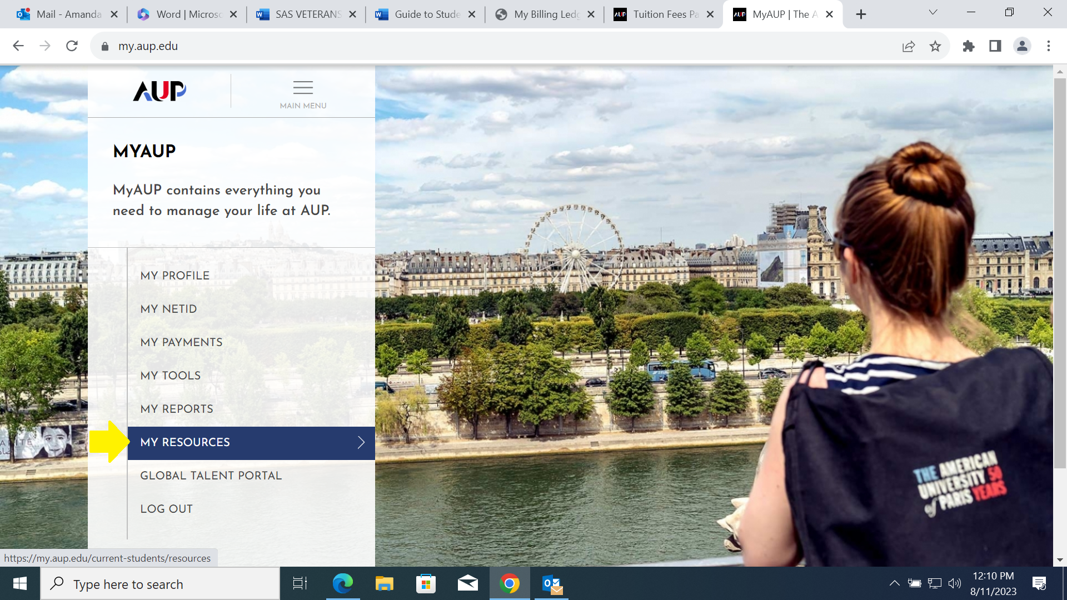
- Under ACADEMIC PLANNING, select Your student portal
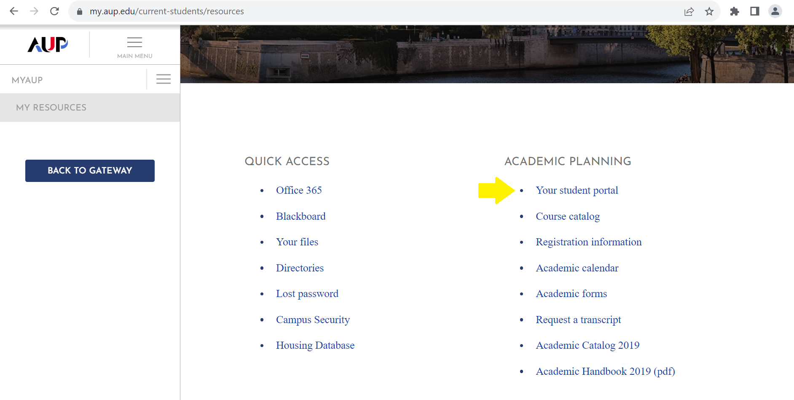
- You will be directed to AUP’s student portal login page. Enter your AUP NetID (e.g. a123456) and password to login
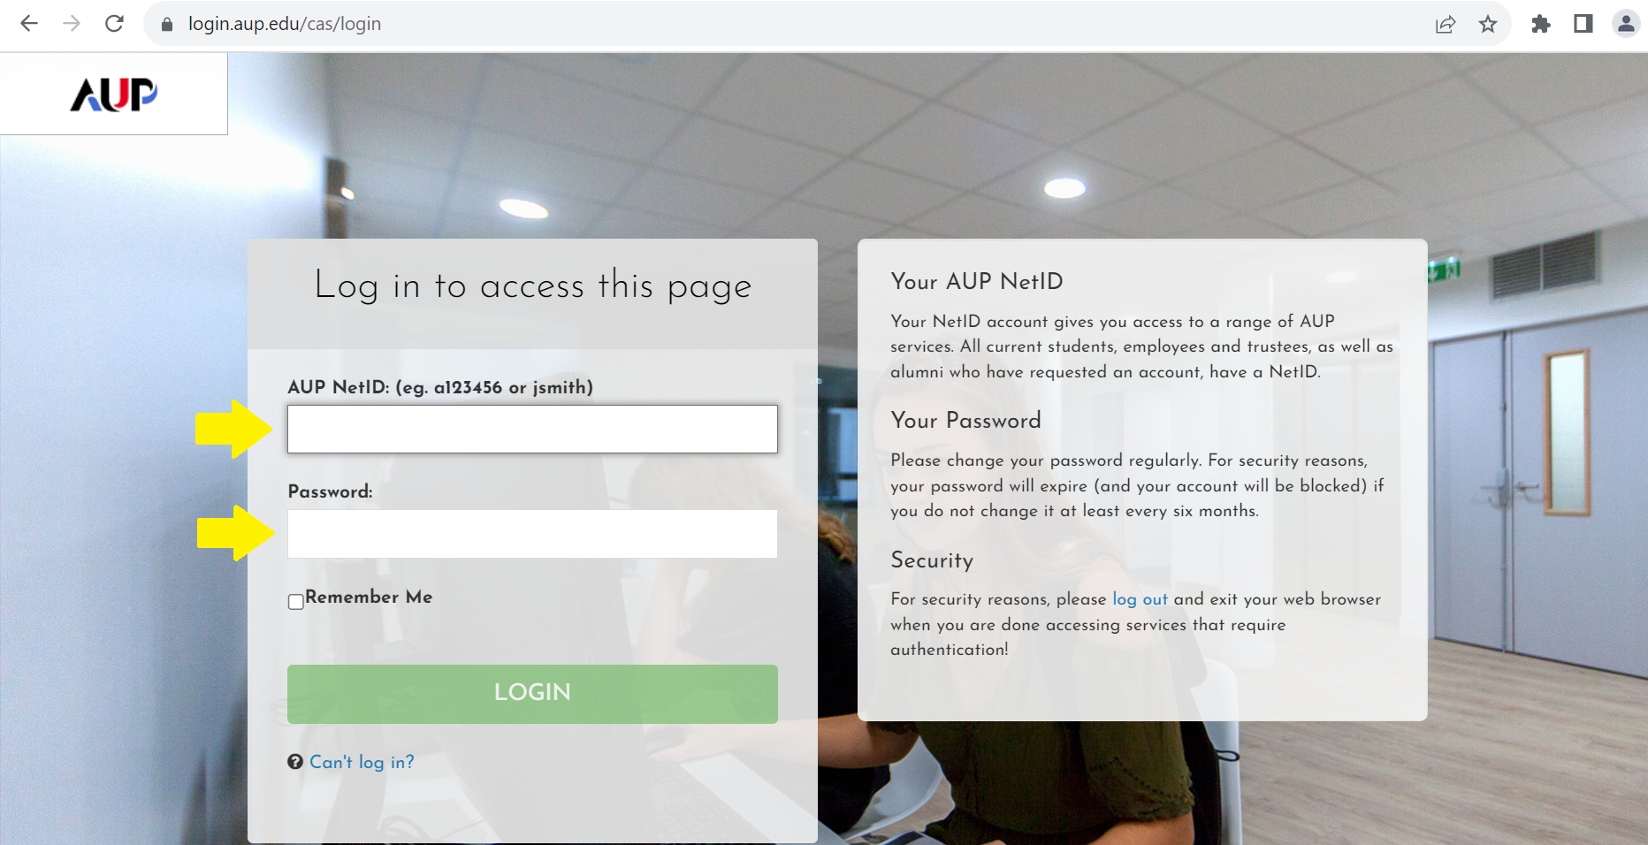

- *If you have problems with login, you may reset your password by clicking the *Can’t log in? prompt where you can select to request a new password. If problems persist, contact AUP IT Services at helpdesk@aup.edu.
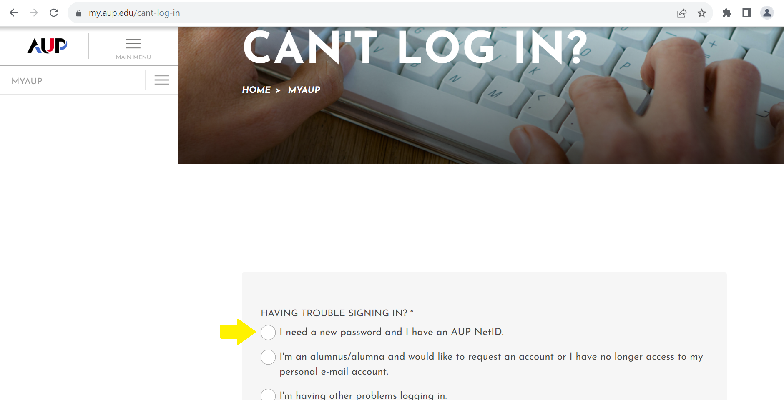

- Once logged in, verify you are in the current semester term. If needed, select Switch Term under student name and ID.
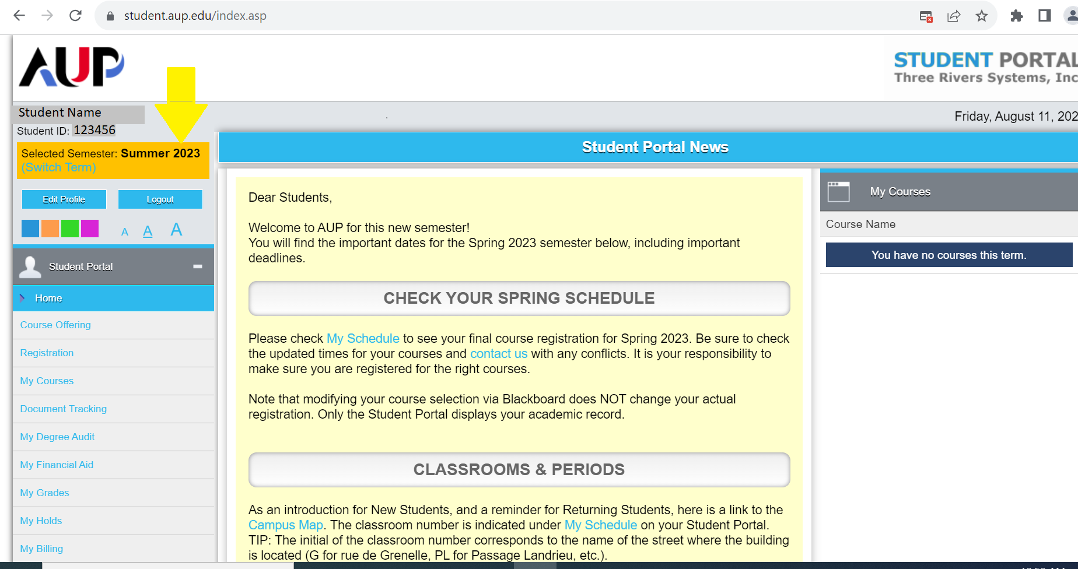
- Under the HOME drop down menu on the left, scroll down and select My Billing.
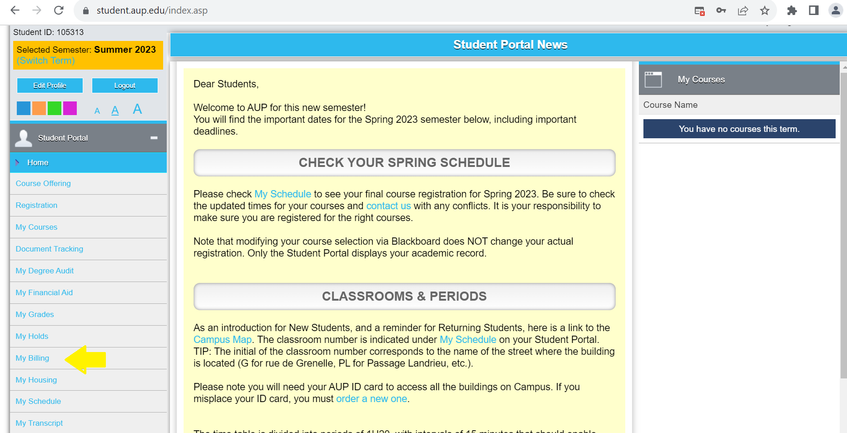
- Current tuition and fees (including orientation fees and health insurance) will be displayed in My Billing Ledger. Pending financial aid and pending house charges are applied to the student’s account with any balances owed by the student displayed as **Overall Balance.
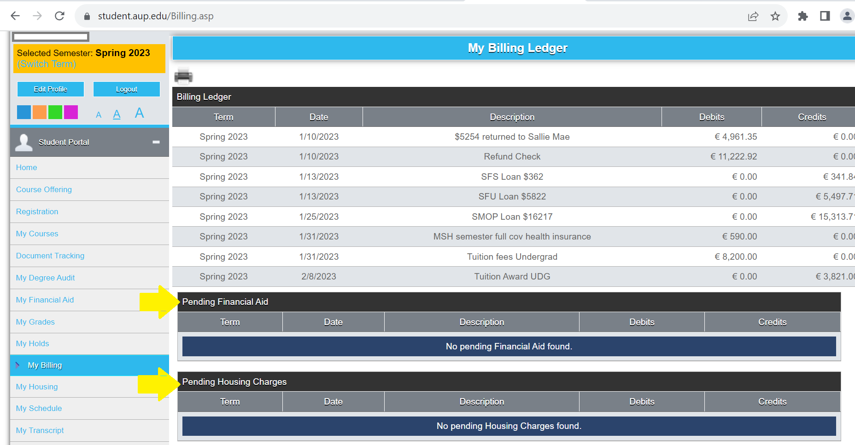
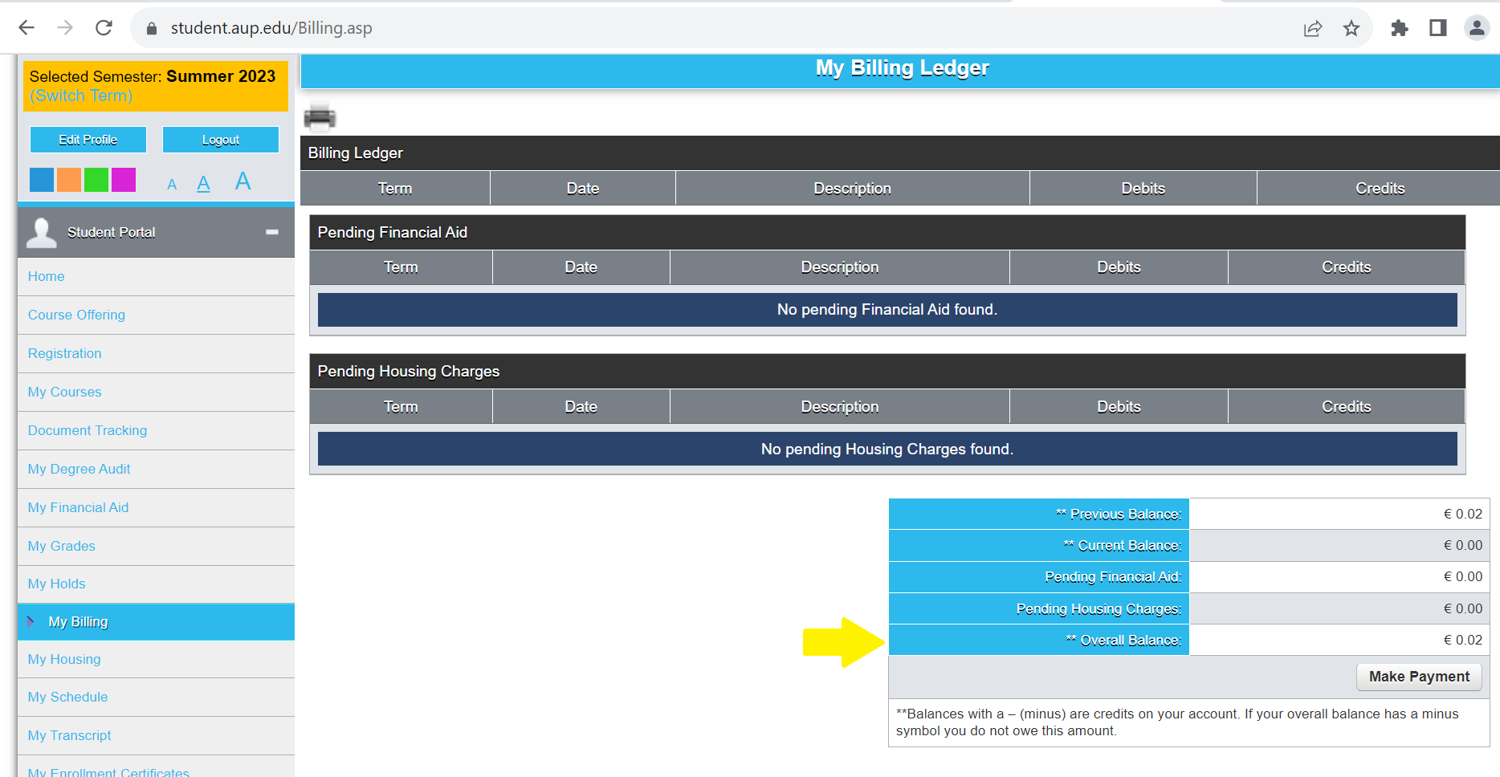

- If you have a balance due, you may pay by selecting Make a Payment.
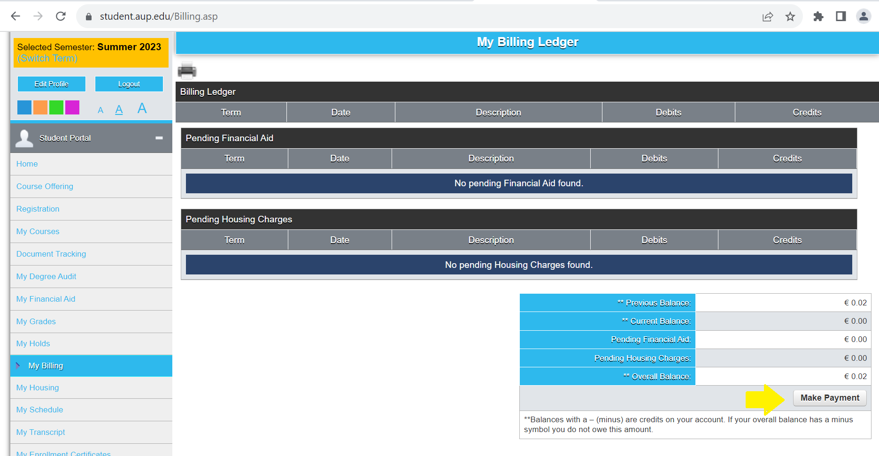
- You will be redirected to AUP’s Tuition and Fees Payment page
*You can make your payment using a credit or a debit card. You also have the option to complete payments via bank transfer or check. You can find the necessary details underneath the online payment form. Please note that wire transfers and checks will take longer to process and confirm.
- To pay by credit or debit card: Complete the Tuition Payment Form with the following
- Add the student ID number
- Select the correct term
- Add the amount in euros (€)
- Click on the blue “Add to Payment List”
- Unless additional payments are being made, click on the blue “Checkout”
- On the next screen, enter the billing information and click on the blue “Continue to Next Step”
- Select your card type and click on the blue “Continue to Next Step”
- Enter the credit card details
- VALIDATE
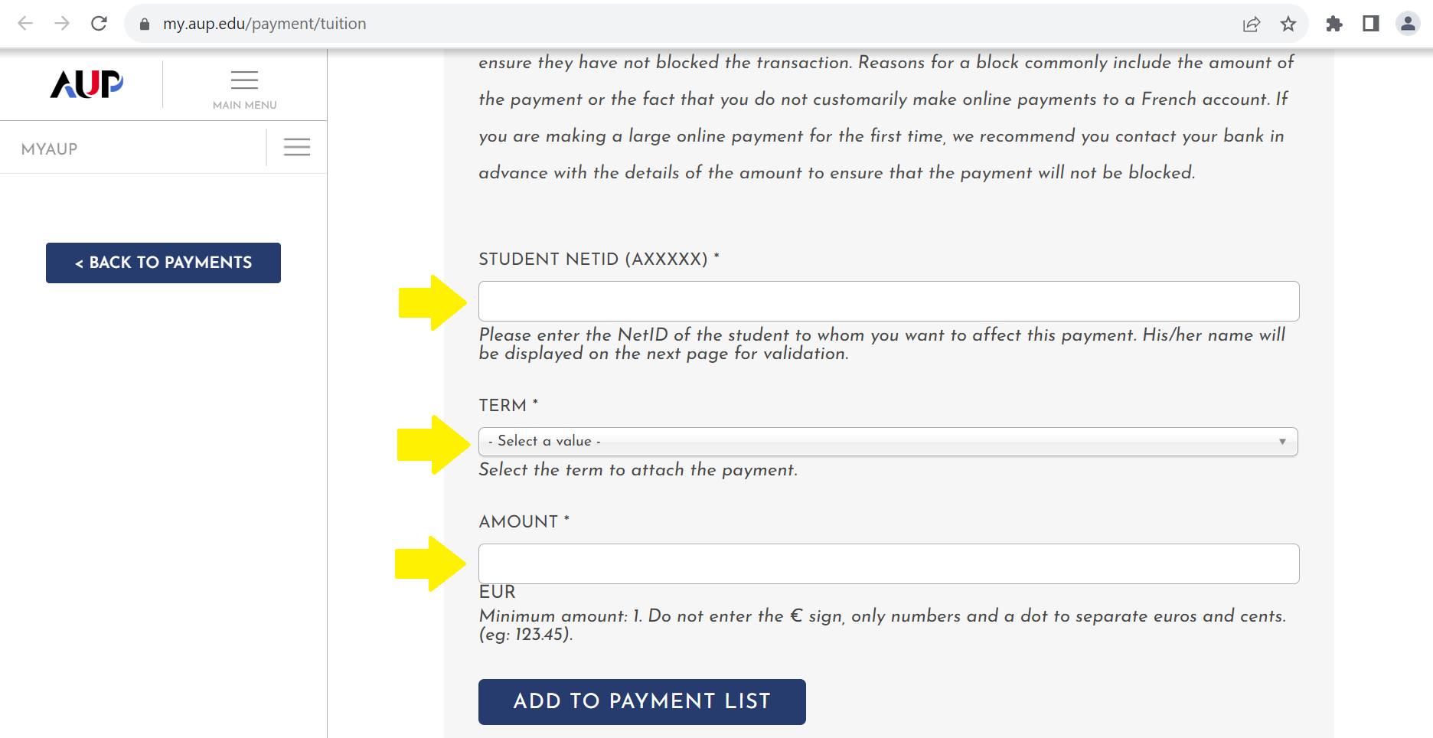* IMPORTANT: This form is only to pay your Tuition Fees. If you want to pay your Housing Fees, please use the Housing Payment Form

- To pay with bank transfer: Scroll to the bottom of page and select Pay with Bank Transfer for AUP bank information. Make sure to include the student’s name and ID in the reference. *Please note: Bank transfers may take up to ten days to be received and should be initiated in time for the University to receive them by the payment deadline.
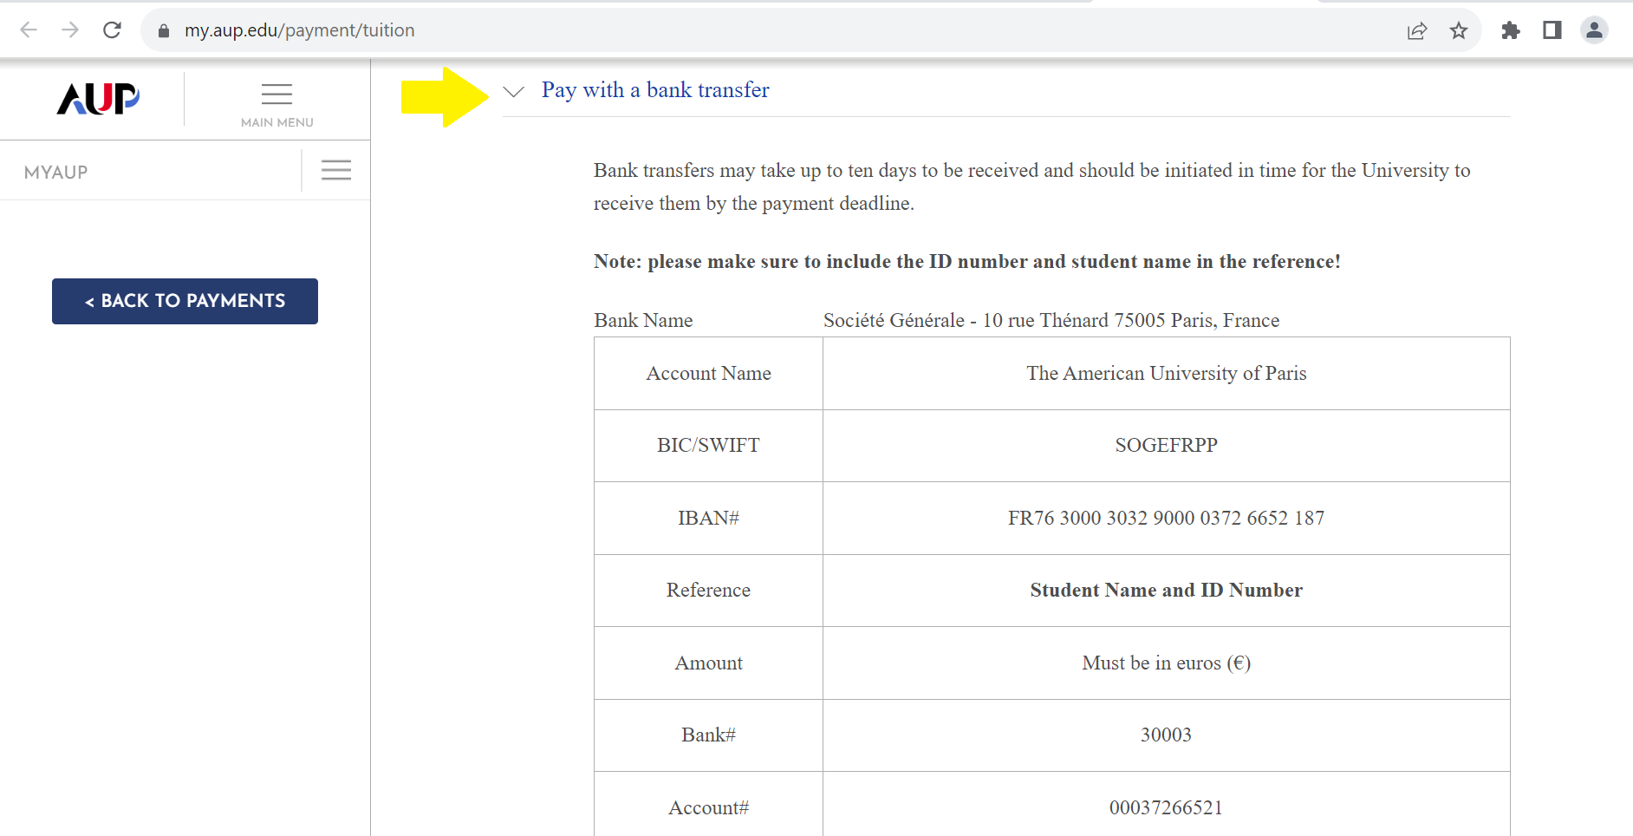
- To pay by check: Scroll to the bottom of page and select Pay with Check for AUP’s billing address. *Please note: Payment must be in euros (€) drawn on a French bank.
