Outcomes Assessment Day May 10th, 2021: Final Report

Dear Colleagues,
On May 10th 2021, we held our annual Outcomes Assessment Day. The objective of the University Outcomes Assessment Day is threefold: first, to allow members of different units to gain a better understanding of each other’s work, plans, challenges, and achievements; second, to share assessment best practices and to support each other in the continuous improvement of assessment processes; third, to propose, develop, and lead focused workshops on key themes than interest a cross-cutting section of the University community. After a few words of welcome from our president, I gave a brief presentation on the advances of the Institutional Effectiveness process at AUP over the last few years (see appendix 1 for PPT presentation). After the presentation, and an ensuing vibrant discussion, participants had a choice of joining one of four 90min. workshops:
- Assessment Methodologies for Complex Objectives; led by Safia Benyahia and Albert Cath
- Assessment of the FirstBridge Information Literacy Learning Outcome through Course Assignments; Led by Laurence Amoureux
- New Courses: Learning Outcomes and Rubrics; Led by Russell Williams, Carla Canelas, and Ruth Corran
- Assessment for Dummies; Led by Claudio Piani

In keeping with the maxim “if there is no report, there was no meeting”, which you all adhere to, I am circulating the notes from the workshop leaders. If there is anything you want to add to these notes, do email me. I will add your comments to this report which will inform the Annual Institutional Assessment report drafted by myself and due in fall 2021.
Sincerely
Claudio Piani

9:15 | Welcome from the Provost
9:30 | Presentation from the Dean of Institutional Effectiveness: Changing assessment at AUP
10:00 | Workshops
10:30
11:00
11:30 | Coffee and viennoiseries*
12:00 | Panel of Rapporteurs
12:30 | Closing remarks
*You will need to provide your own.

Outcomes Assessment Day Schedule

Workshops

Assessment Methodologies for Complex Objectives
  - Led by Safia Benyahia and Albert Cath
Description of the workshop: Administrative units all serve AUP’s mission, directly or indirectly, and some units center around complex, human-centered services whose impact is essentially impossible to fully measure (e.g., counseling, leadership, and career development). This workshop centers around the methodologies section of the assessment report for units with similarly complex objectives. We hope that participants will leave the workshop with better assessment methods & tools, as well as a sense of readiness to embrace the complexity of their mission at AUP.

Planned activity: We will give a 5min introduction to complexity theory and useful definitions. Then, we will give participants a series of exercises that they can apply to their unit. We will start with more abstract questions to help participants think outside the box and not shy away from setting complex goals for their units. By the end of the session, participants will have developed additional methodologies (and possibly objectives) that they can incorporate into their assessment strategies.

The activities and questions will address the following topics:
- Highlight and embrace the complexity of AUP’s mission and each unit’s mission
- Identify mission-critical elements that don’t currently appear in the assessment report (important but intangible variables such as soft skills, relationships, or personal growth)
- Why should we (or why should we not!) incorporate these variables into assessment?
- Sharing tools & methods to incorporate these variables into assessment reports
- Closing thoughts and recommendations

Planned outcomes:
- Colleagues will have made progress on the “assessment methodology for the objective” section of their report. They may develop new tools & evidence for existing objectives or redefine their objectives.
- Colleagues will develop strategies to help them tackle complex objectives that are central to their unit’s missions. This is founded on the belief that it’s better to assess what’s difficult to measure to the best of our ability than to over-simplify the assessment process and ignore important variables.
- They will leave the workshop excited about assessment!

Notes from meeting from Safia Benyahia:

- We opened with a storyboarding exercise as a tool to help build a bridge between our lived realities that we must translate into a report with written text and numbers. The idea is that drawings could better articulate the in-between (inspired by a talk given by Joe Gebbia, co-founder of Airbnb)
- Participants shared drawings that depicted a lived reality that they don’t know how to effectively translate into an assessment model.
- Albert Cath gave a 5min “crash course” on managing in complexity. The main take-away was that standard assessment tools work well for simple objective and there are other methodologies for (imperfectly) assessing emergent, chaotic and complex situations that arise in reality.
- We went back to our storyboards and discussed how to tie our objectives to AUP’s mission via storytelling (this is particularly useful when our activities serve AUP’s mission indirectly, as is the case for most administrative units)
- We encouraged participants to go ahead and set complex objectives for themselves (that link with the mission and strategy), keeping in mind that they don’t need definitive conclusions or scientific proof. The idea is to embrace the complexity of our activities and that it’s better to imperfectly incorporate these lived experiences into our assessment practices than not at all.

The discussion also touched on other points brought forth by participants:
• The time that assessment takes and balancing that with executing our mission
• The phrasing of our objects, as we’ll never be able to assess vague objectives
• We realized that we’re all in the same boat! For admin, our services often have an indirect impact on the student learning experience, which adds a layer of complexity to our assessment. Faculty members talked about human interactions and learning outcomes that they experienced in their classrooms but couldn’t easily incorporate in their reports (after all, learning and human relationships are complex)
- Admin units weren’t clear as to who read their report and how it was used beyond self-reflection on how to improve their units, if it influenced decision-making at the higher level or not.

People were very engaged, so the discussion was dynamic and we didn’t have time to carve out real objectives and methodologies together. We gave them some tips from complexity theory that they could use when they tackle their assessment reports.

Assessment of the FirstBridge Information Literacy Learning Outcome through Course Assignments.
  - Led by Laurence Amoureux
The purpose of this session, meant for FirstBridge Faculty and Librarians, is to get together as a group and make progress with the assessment of the FB Info Lit LO.
We will meet both as a whole group and subgroups* of faculty with their liaison librarians to discuss course assignments (bring your draft syllabus or at least your students’ assignments) and how they could be best used to assess the Info Lit LO**. Meeting in advance as a group will allow us to prepare by sharing experience regarding the assessment of that specific LO. At this point, an analytic grading rubric for a specific assignment - an annotated bibliography - has been validated by GLACC and shared. Building upon this first step, we will aim at coming up with a method understood and approved by all, as simple as possible while keeping the assessment of information literacy harmonized over all FB and owned by both faculty and librarians.
* Teams breakout rooms
** FB Info Lit LO: “Students will acquire an understanding of how information is produced and valued in order to discover, evaluate, use, and create information and knowledge effectively and ethically. In FirstBridge/EnglishBridge, students will develop an awareness of the conversational nature of scholarship, and of their potential role and responsibilities as contributors to that conversation. For each discipline taught in FirstBridge/EnglishBridge, students will be able to identify reference works, journals, databases and/or major works, in order to start effective research in the field.”

Notes from meeting from Laurence Amoureux:
OUTCOMES for this session
- Reach a common understanding on what is expected of us (GLACC & IESC)
- Agree on acceptable forms/methods of assessment (IESC)
- Agree on some level of faculty/librarian collaboration (course)
- Reflect on info lit in FB and at all levels as info lit is not just a FB/FYE concern (not covered)

- Information Literacy and GLACC
- Clarify assessment process
- Fall 2020 changes, where we are
- Fall 2020: feedback from all
  - Coverage of LO for information literacy: just one LO, to be covered in simple ways – using course assignments rather than creating new assignments
  - For assessment, the more librarians and faculty collaborate, the more pleasant and effective for the students – co-grading for the proposed assignments
  - A grading rubric has been elaborated (for lists of works cited), it's very complete and analytic; faculty would grade the quality of the source, librarians would grade the format
  - Collaboration in FA20 was not entirely clear, but the grading rubric came in quite late.
  - FA21 will be the second experience with this form of assessment.
  - No overlap with CCI LOs and Info Lit LO – requires separate assessment.
- Fall 2021: Planned course assignments & Info Lit assessment - (Appendix 2)
  - Courses with an annotated list of works cited assignment were identified
  - Courses with other types of assignment were identified
Librarians and faculty will meet again before Fall to finalize details (assignments, assesst, timing, training (ex. Zotero))
Here are the main questions raised and answered:
- How many assignments for info lit are idea in an FB? One bridging exercise? Two different types of assessment? One housed only in one class?
- What will collaboration look like according to the type of assignment?
- Idea for an assignment: evaluation of popular websites in terms of credibility and quality?
- How to evaluate students when they have trouble difficulty evaluating the quality of a source?
- Zotero: is it a tool that could be encouraged in info lit sessions? Could the teacher be taught first? Requires a lot of hands on work with students and that could take up all the of the session.
- How would reading quizzes and comprehension exercises be used in the info lit LO?
- Importance of developing a research question early in the semester that is sufficiently narrow and can be managed – takes time.
- Research log assignment: to see how students are actually finding information – focuses on research process.

- Discuss: Single info lit grading rubric for all types of assignments – Seen briefly
  - A simplified version would be really useful; the detail and care of the current version is remarkable.

- Future: Info Lit across curriculu – NOT COVERED
  - What do people think of a document listing vertical progression of info lit skills proficiency levels?
  - Volunteers?
  - Milestones?

- Planned actions for 2021 – NOT COVERED
  - Suggestions from profs/librarians other than the ones listed

New Courses: Learning Outcomes and Rubrics
  - Led by Russell Williams, Carla Canelas, and Ruth Corran
This session, led by the AUP Curriculum Committee, aims to give Faculty a no-nonsense overview of the steps involved in getting a new course up-and-running at our institution. After a brief presentation of the Curriculum Committee’s efforts to make this process as manageable and meaningful as possible, Faculty will be invited to discuss key issues in moderated break-out groups.
After attending the training session, those attending will be able to
- confidently describe what information is needed to propose a new course to Curriculum Committee
- write clear Learning Outcomes that will be appreciated by your students, easily assessable by you and approved by Curriculum Committee
- create useful and worthwhile rubrics for evaluating the achievement of those Learning Outcomes
- identify meaningful criteria for the achievement of a Learning Outcome

Notes from meeting from Carla Canelas Tobar:
The workshop 'New Courses: Learning Outcomes and Rubrics' started with the presentation of the form for 'new course' submissions to the Curriculum Committee.

This was followed by the presentation of two examples concerning learning outcomes and their respective assessment methodology. For the course 'Digital Poetics' the assessment methodology included the use of a rubric, while for the 'Calculus' class, the assessment methodology relied on a blueprint.

After both examples were presented, the group discussion focused on assessment. Several questions/concerns were raised by different faculty members, in particular:

- Do all the learning outcomes of a course need to be assessed or only those which are aligned with a program?
- Is there/should there be discussions about a ‘standard four-point scale’ that all courses should/could adopt? (Excellent, Good, Satisfactory, Unsatisfactory)?
- Is there/should there be discussions about a ‘standard proportion” as criterion for LO being achieved? (Some departments use 50%, some 60%, …)
- Is there/should there be discussions about moving towards more automation of the process – eg for submission of results and conclusions, in tabular form, via an online form or similar?
- Also, Faculty would appreciate a clear statement from AA about whether all LOs are assessed each year or not, as well as a clear definition from AA about what an acceptable rubric involves.

Assessment for Dummies
  - Led by Claudio Piani
New to assessment? Unenthused? Assessment should not be overly burdensome and it should not be something that you need to do perfectly on your first attempt. MSCHE is very much in support of “continuous improvement”. So long as you incrementally strengthen your assessment process, you are in compliance with your assessment requirements.
In this work shop I will assist you in setting up the most basic form of assessment and assessment reporting for a course of your choice. By the end of the session, you will have:
- Identified an assessment method for a learning outcome of your choosing (test, presentation, or other artifact).
- Drafted an evaluation rubric or blueprint for that LO and that methodology.
- Drafted an assessment report.

Notes from meeting from Claudio Piani:
I started with a PPT presentation on how to develop and implement a very simple assessment structure for a course (Appendix 3). This was followed by an intense Q&A session that, while getting in the way of the planned exercises of the workshop, revealed some important information gaps that needed filling. Below is a list of the questions I can remember and the answers I gave.
- The CCI LOs are very broad. Too broad to assess. Should I just give up and not propose a CCI class?
No, I suggest you develop a LO that is “included” or is aligned with the CCI and use that as your assessment result.
- What should I do with CCC LOs? I do not do both LOs in my capstone/ senior project
You only have to choose one of the CCC LOs.
This is true of CCI as well, you only need to pick 2 out of 4. You do not get brownie points for picking three.
- Do I have to have a question for every LO in every quiz I give?
No, you do not have to use every quiz/test/essay/other as an assessment method. But if you use one, it has to be with a rubric or blueprint.
- Assessment is a standardizing and impoverishing process. It is useless busy work . No good can come of it. (statement not question)
It could become that and our challenge is to make sure it does not. Also, we did get our accreditation revoked last May, remember? I do not think we have the option of “not doing it”.

Appendix 1: Continuous Improvement at AUP 2021 (PPT Presentation)
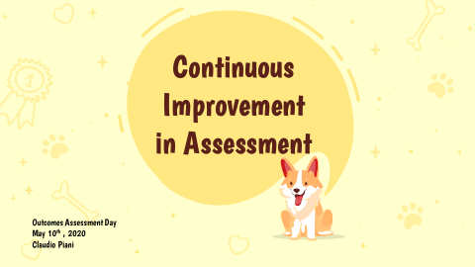
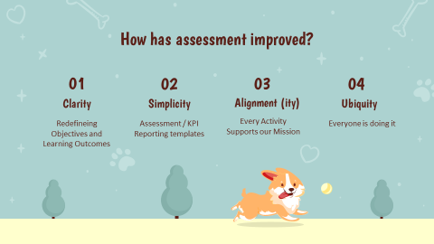
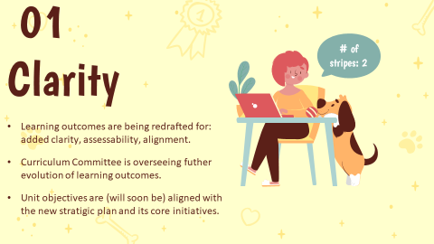
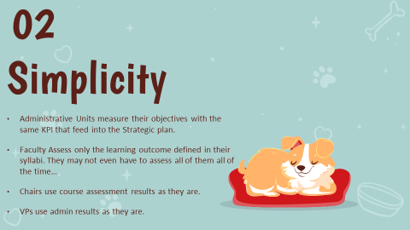
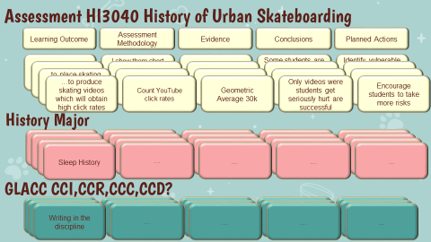
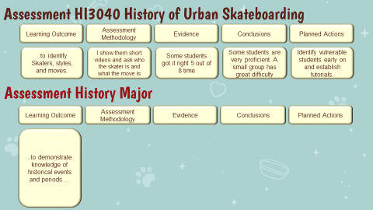
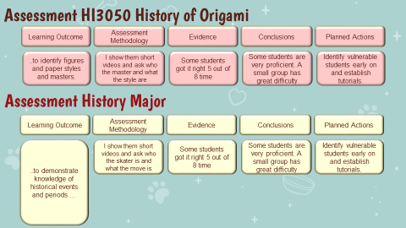
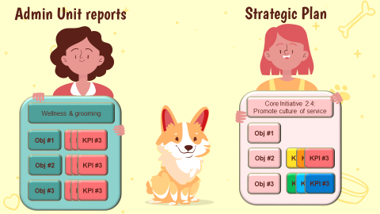
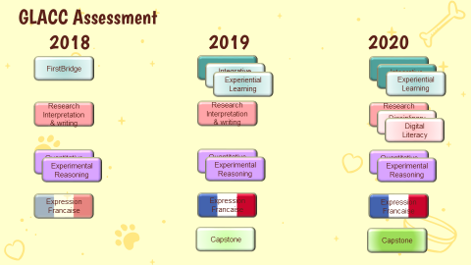
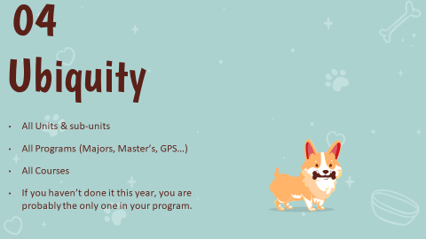

Appendix 2: Planned course assignments & Info Lit assessment

 |  |  |  | Info Lit Assessment via…
Librarian | Professor | Discipline | Assignments | (Annotated) List of works cited required | Other type of assignment
Sally | Sneharika Roy | CL | Group presentation, Home assignment, Comparative essay | not an issue in literature | Popular websites evaluation in both math and science fiction
 | Francesca Balestrieri | MA | NEW in FB  "Specific exercises, where the students can experience directly how changing axioms and rule affect the resulting mathematical and logical architectures; " | Seems like "no"?
Sally | Sneharika Roy | CL | Group presentation, Home assignment, Comparative essay | TBC | Include Zotero assignment but learn it first before teaching it.  Students would collect sources on rituals (for ex.) and the group would end up with a collective list.
 | Tanya Elder | CM | Research project on anthropologist. Visual map + oral presentation | yes, with annotation?
Laurence | Linda Martz | HI | Individual research presentation (+ annotated bbg)  Group project on a survivor or witness of a genocide (VHA) + with Paris locations + Mapping physical trajectory  Joint project with AH course ??? | yes
 | Iveta Slavskova | AH | Group oral presentation on one artwork  Final paper on one artwork  Joint project with HI course ??? | yes. Maybe not for joint project. | Questions about the readings every week
Michael | Linda Martz | HI | Individual research presentation (+ annotated bbg)  Group project on a survivor or witness of a genocide (VHA) + with Paris locations + Mapping physical trajectory  Joint project with AR course - Design a Museum | yes
 | Jonathan Shimony | AR
Michael | Julian Culp | PL | Reflection statements  End of term paper | yes
 | Jessica Feldman | CM | Short presentation on a reading of their choosing  Reading responses and report-backs of assigned visits/talks  Draft bibliography, research question  Final paper | yes, with annotation?
Jorge | Ziad Majed | HI ME | Details needed  Case studies | TBC
 | Rebekah Rast | LI | Small group or individual research project on a specific language  Research project and presentation of research | yes, with annotation?
Jeff | Gail Hamilton | BA | *A small research paper on a business hero and the sector (alternatively a field research project on the retail apocalypse)  *A management decision-oriented research paper on the US sports naming conundrum. Students will identify a process for change and/or make recommendations.  *A team field research project – what did we read & watch during lockdown? Has our behavior changed? How can we use this information from a consumer behavior point of view?  *A final reflective paper ‘who do I want to work for and why’ which pulls together the Integrative Inquiry LOs while asking students to think about their own values as well as different sectors and functions in a company | yes, possible to ask for annotations  Data collection in the field | Spend a lot of time on developing research questions
 | Russell Williams | CL | In class essay  At home essay  Research Paper (with bibliography) | yes, with annotation?
Michael | David Tresilian | CL | Presentation assignments, including video  Research paper | yes, with annotation?
 | Justin McGuinness | CM ME | Presentation of a country in a Middle East or North African region  Essay on a set of articles  Presentation to class of essay on a set of articles  Podcast and accompanying note | TBC
Jorge | Daniel Medin | CL | Oral presentation on one of the assigned readings  Two detailed response papers (informal essays)  Final project = autobiographical document marked in some way by the approches of our authors + Reflective essay about the process of preparing this document | TBC
 | Hervé Vanel | AH | Short response paper [Museum Visit]  Final Presentation [Oral]  Final Paper [Exhibition Prospectus] | yes, with annotation?
Jorge | Cary Hollinshead-Strick | CL | Weekly assignments  Curatorial project Details needed  VHA project Details needed  Paper developped from a weekly assignment | TBC
 | Raphael Bloch-Lainé | FR HI | NEW in FB  Presentations (PowerPoint)  Debate  Pamphlet writing | Yes, annotated | Zotero training?
Laurence | Elizabeth Kinne | CL GS | Press project 30% (reviews of 3 press articles)  Comparative research project with annotated bbg 30%  Joint project with Elena 15% | yes | How to read a scholarly article  Where do you get your information from?
 | Elena Berg | IDISC SC | Press article Analyses  Short comprehension quizzes  Individual research project  Joint project with Elizabeth (video) | yes

Appendix 3: Assessment for Dummies
