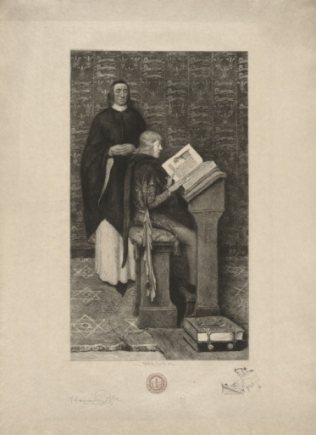 | Writing Lab  Peer-Tutoring Application Form

Name:
Student ID: |  | Class Standing:
E-mail: |  | Phone:*
Major(s)/
Program:
Minor(s):
Expected Semester of Graduation:

*Your cell phone number is for internal use only. It will not be given to students.

Do you expect to receive a student grant from AUP? Yes No

We will contact you to arrange an interview with Professor Ann Mott, the Writing Lab Director. If you are a returning AUP student, please ask two professors (one of whom must be an EN professor) for whom you have completed a writing assignment for letters of recommendation. Please also submit graded papers from previous semesters.

Please return this form to the Writing Lab via e-mail, campus mail, or in person:

Writing Lab
147, rue de Grenelle
75007 Paris, France
Tel: 01.40.62.06.72 or 01.40.62.06.52
E-mail: writinglab@aup.edu or amott@aup.edu

Semester: 2017 Spring

Number of hours per week you would like to tutor per week:

Please fill in the timetable with your class schedule for the semester
and the period(s) when you are free for tutoring.

 | MON | TUE | WED | THU | FRI
Period 1
9:00–10:20
Period 2
10:35–11:55
Period 3
12:10–13:30
Period 4
13:45–15:05
Period 5
15:20–16:40
Period 6
16:55–18:15
Period 7
18:30–19:50
Period 8
20:05–21:25

For internal use:
Date:
Notes:

