CURRICULUM PROPOSAL FORM: NEW COURSE

Title of Proposal: | …
Author of Proposal: | …
Author’s home department: | …

Required Supporting Documents
The following required* documents must be uploaded to the CC Sharepoint
Please name your document with your last name, type of proposal, title of proposal and document type (e.g. HOBART New Course Fabulous Renaissance Cover Letter)
☐ *This cover sheet completed with all signatures and dates
☐ *Minutes of departmental meeting
☐ *Complete syllabus, along with the number and nature of classroom hours (is there a visiting period or a lab, for example) and the learning outcomes and assessment methodology for the course
☐ *New resources needed (ARC, ITS, Library, Faculty). Where new resources are needed, include a PDF of the ARC director, IT Director, University Librarian, or Provost’s response email.
☐ Updated assessment documents if curricular modification
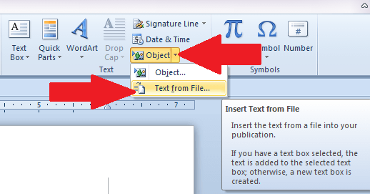
If you need admin support to finalize your proposal, please contact Lilyana Yankova at lyankova@aup.edu
Use the Text from File function under Insert/Object/Text from File to insert your files into this word document.

Course Titles
Please provide new title information in both English and French. 50 characters max (including spaces).
Title in English | …
Title in French | …

Catalog Course Description
(60 words or less) including prerequisites
…

Longer Course Description
(200 words or less) including prerequisites
…

Degree Requirement Rationale
Describe where on the department degree requirement sheet the course should fit. Is it a core course or an elective? Does it count towards a minor? If the course also counts towards another department’s degree requirements, please explain its role in that degree too.
…

Course Replacement
What course(s), if any, will it replace?
…

Pre-requisites
Are there any pre-requisites? If yes, which?
…

Course Level and Number of Credits
What level is the course? 1000, 2000, 3000, 4000, 5000? How many credits is the course worth?
(Credit verification is required by Middle States. We need to demonstrate that a 4-credit class is worth four credits, etc.)
…

Previous Topics Course
Was the course offered as Topics before? If yes, how was the enrollment?
…

Semester that Course Will Next Be Offered
When will the course be offered next? New courses will be offered with their new course codes in the upcoming semester but only once approved by Senate and once MEMO is published. The course will be integrated in the Academic Handbook in the following academic year.
…

Impact on University Resources
Reminder, where new resources are needed, include a PDF of the ARC director, IT Director, University Librarian, or Provost’s response email.
Does this proposal require new library resources? (library@aup.edu)
☐ Yes ☐ No
Does this proposal require any IT resources for this course? (helpdesk@aup.edu)
☐ Yes ☐ No
Does this proposal require any additional resources from ARC? (arc@aup.edu)
☐ Yes ☐ No
Does this proposal require any new faculty?
☐ Yes ☐ No
Does this proposal require other new resources?
☐ Yes ☐ No If yes, please elaborate below.

Use of Paris in our Curriculum
Does this curricular change impact or change the strategic pedagogical use of Paris or its environs in the program in question?
…

Alignment with Program Learning Outcomes
Demonstrate alignment with program learning outcomes using the curriculum alignment matrix for the program(s) (including general education) that this course will serve.
…

Global Liberal Arts Core Curriculum Requirement – Do you wish this course to be considered for qualification as a course that fulfills a GLACC requirement?

☐ Yes | ☐ No

Approvals
Graduate Program Director Approval, if applicable
Graduate Program Director’s Signature |  | Date
☐ Approved |  | ☐ Not Approved
Graduate Program Director’s Comments
Department Chair Approval
Department Chair’s Signature |  | Date
☐ Approved |  | ☐ Not Approved
Department Chair’s Comments
Curriculum Committee Approval
Curriculum Committee Chair’s Signature |  | Date
☐ Approved |  | ☐ Not Approved
Comments
Academic Affairs Approval
Associate Dean’s Signature | Date
☐ Approved | ☐ Not Approved
Comments

