CURRICULUM PROPOSAL FORM: NEW PROGRAM
UNDERGRADUATE MAJOR, MINOR OR GRADUATE PROGRAM

Title of Proposal: | …
Author of Proposal: | …
Author’s home department: | …
Type of Program (tick one): | ☐ Undergraduate Major ☐ Undergraduate Minor  ☐ Graduate Program

Required Supporting Documents
The following required* documents must be uploaded to the CC Sharepoint
Please name your document with your last name, type of proposal, title of proposal and document type (e.g. BONNEAU New Minor Entrepreneurship Cover Letter)
☐ *This cover sheet completed with all signatures and dates
☐ *Minutes of departmental meeting
☐ *Demonstration of potential market (from Admissions and personal research)
☐ *Filled-in assessment structure (See Appendix 1 and 2) approved by the Associate Dean for Educational Assessment (see end of document)
☐ *New resources needed (ARC, ITS, Library). Where new resources are needed, include a PDF of the ARC director, IT Director, University Librarian, or Provost’s response email.
☐ Updated assessment documents if modified by curricular modification
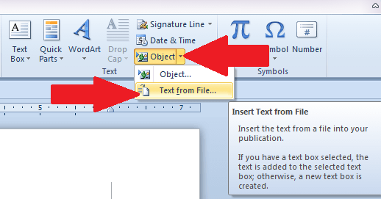
If you need admin support to finalize your proposal, please contact Lilyana Yankova at lyankova@aup.edu
Use the Text from File function under Insert/Object/Text from File to insert your files into this word document.

Major, Minor, or Graduate Program Name
Please provide the information in both English and French
In English | …
In French | …

Strategic Alignment Rationale - Rationale, and how the new program aligns strategically with the Institutional Learning Outcomes and AUP’s academic master plan
(All new programs – majors, minors, and Master’s – require approval by the Provost before consideration by the Curriculum Committee. Please note that the change will be effective in Handbook as of the next academic year.)
…

Implication for Other Departments
Please identify this information for all courses included: are they cross-listed, do they currently fulfill core or elective requirements of other majors/minors, etc.
…

Major, Minor, or Graduate Program Requirements
WARNING: If you have new courses in the major, minor, or graduate program, you should have submitted a new course request for each new course.
…

Description of New Major, Minor, or Graduate Program
Description of the new major/minor, suitable for inclusion in the catalog
…

Impact on University Resources
Reminder, where new resources are needed, include a PDF of the ARC director, IT Director, University Librarian, or Provost’s response email.
Does this proposal require new library resources? (library@aup.edu)
☐ Yes ☐ No
Does this proposal require any IT resources for this course? (helpdesk@aup.edu)
☐ Yes ☐ No
Does this proposal require any additional resources from ARC? (arc@aup.edu)
☐ Yes ☐ No
Does this proposal require any new faculty?
☐ Yes ☐ No
Does this proposal require other new resources?
☐ Yes ☐ No If yes, please elaborate below.

Alignment with Program Learning Outcomes
Demonstrate alignment with program learning outcomes using the curriculum alignment matrix for the program(s) (including general education) that this course will serve.
…

Approvals
Graduate Program Director Approval, if applicable
Graduate Program Director’s Signature |  | Date
☐ Approved |  | ☐ Not Approved
Graduate Program Director’s Comments
Department Chair Approval
Department Chair’s Signature |  | Date
☐ Approved |  | ☐ Not Approved
Department Chair’s Comments
Curriculum Committee Approval
Curriculum Committee Chair’s Signature |  | Date
☐ Approved |  | ☐ Not Approved
Comments
Academic Affairs Approval
Associate Dean’s Signature | Date
☐ Approved | ☐ Not Approved
Comments

APPENDIX 1 – ASSESSMENT STRUCTURE FOR NEW MAJORS
Department: <DEPT NAME>
Department's Mission statement
<PROGRAM NAME>
Learning outcomes of the major
If the learning outcomes of the program have changed in the period being assessed, please create more tables with the set of learning outcomes holding in each period
learning outcomes <PROGRAM NAME>
Learning outcome | Assessment methodology for learning outcome
<PROGRAM LO> | - <ASSESSMENT METHODOLOGIES>
<PROGRAM LO> | - <ASSESSMENT METHODOLOGIES>

Program alignemnt Matrix (see help in appendix 2)
(Place a mark when the program learning outcome contributes to the institutional learning outcome)
Institutional learning outcome / Program learning outcome (from matrix above)  Our students will: | <PROGRAM LO> | <PROGRAM LO> | <PROGRAM LO> | <PROGRAM LO>
Communicate well in a world of many languages
Think critically
Develop creative interdisciplinary approaches to important contemporary challenges
Be both technologically and culturally literate in a world of swift-paced change
Understand the ethical imperatives of living in a world of swift-paced change
Take their places as responsible actors in communities, civil societies, and countries around the globe

Course Sequence <PROGRAM NAME – COURSE SEQUENCE NAME>
Optional narrative

Curriculum Alignment Matrix <PROGRAM – COURSE SEQUENCE>
I = introduced (the student understands this but will not be able to do this properly)
P = practiced (the student is expected to use this but not to have fully mastered it)
D = demonstrated (the student can be expected to do this consistently and accurately)
learning outcome | COURSE | COURSE | COURSE | COURSE | COURSE | COURSE | COURSE | ELECTIVES GROUP | THESIS / INTERNSHIP
<PROGRAM LO> | I
<PROGRAM LO>
<PROGRAM LO>
<PROGRAM LO>

APPENDIX 2 – ASSESSMENT HELP

Sample help document for assessment
(more details will be available online)

Mission Statement
A broad statement of the goals, values and aspirations of the unit, department, or program.
Example for an academic department: The Psychology Department has an active faculty and involved students. Through research and coursework, independent theses and informal interactions, the psychology faculty offer students a superior undergraduate experience and strive to fulfill the mission of the college as well as addressing the goals outlined below.

Learning Outcomes
Learning outcomes are statements of the knowledge, skills and abilities individual students should possess and can demonstrate upon completion of a learning experience or sequence of learning experiences.
You should develop 3-5 learning outcomes for your program. MSCHE provides guidelines in chapter 2 of the handbook on Student Learning Assessment: Options and Resources (2nd Edition, 2007). I would reccomend however this more practical guide of the University of Richmond (see section 3 on creating learning outcomes). Here is a quick summary:
- Learning outcomes should be specific and well defined
- Learning outcomes should be realistic
- Learning outcomes should rely on active verbs in the future tense
- Learning outcomes should be framed in terms of the program instead of specific classes that the program offers
- Learning outcomes should align with the program’s curriculum (see alignment matrices: for alignemnt of program to institution and alignment of courses to programs)
- Learning outcomes should be simple and not compound
- Learning outcomes should focus on learning products and not the learning process
Bloom’s Taxonomy of Educational Objectives (1956) is one traditional framework for structuring learning outcomes. Levels of performance for Bloom’s cognitive domain include knowledge, comprehension, application, analysis, synthesis, and evaluation. These categories are arranged in ascending order of cognitive complexity where evaluation represents the highest level. The table below presents a description of the levels of performance for Bloom’s cognitive domain.
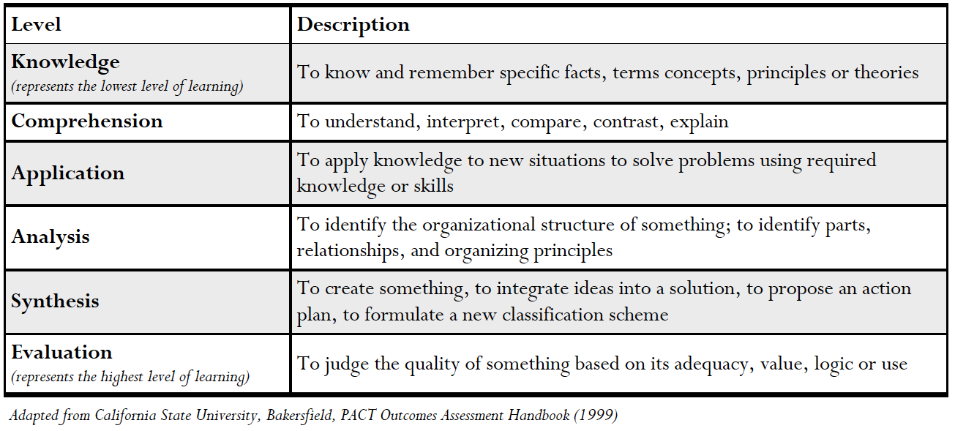
Sample Learning Outcomes
- Languages and Literature:
  - Students will be able to apply critical terms and methodology in completing a literary analysis following the conventions of standard written English.
  - Students will be able to locate, apply and cite effective secondary materials in their own texts.
  - Students will be able to analyze and interpret texts within the contexts they are written.
  - French students will be able to demonstrate oral competence with suitable accuracy in pronunciation, vocabulary, and language fluency.
  - French students will be able to produce written work that is substantive, organized, and grammatically accurate.
  - French students will be able to accurately read and translate French texts.
- Humanities and Fine Arts:
  - Students will be able to demonstrate fluency with formal vocabulary, artistic techniques and procedures of two dimensional and three-dimensional art practice.
  - Students will demonstrate in-depth knowledge of artistic periods used to interpret works of art including the historical, social and philosophical contexts .
  - Students will be able to critique and analyze works of art and visual objects .
  - Students will be able to identify musical elements, take them down at dictation, and perform them at sight.
  - Students will be able to communicate both orally and verbally about music of all genres and styles in a clear and articulate manner.
  - Students will be able to perform a variety of memorized songs from a standard of at least two foreign languages.
  - Students will be able to apply performance theory in the analysis and evaluation of performances and texts.
  - Students will be able to analyze and interpret scripts.
  - Students will demonstrate in-dept knowledge and understanding of contemporary theatre forms and artists.
  - Students will be able to demonstrate proficiency in a variety of dance styles, including ballet, modern dance, jazz, and tap
- Physical and Biological Sciences:
  - Students will be able to demonstrate an understanding of core knowledge in biochemistry and molecular biology.
  - Students will be able to apply critical thinking and analytical skills to solve scientific data sets.
  - Students will be able to apply the scientific method to solve problems.
  - Students will be able to demonstrate written, visual, and/or oral presentation skills to communicate scientific knowledge.
  - Students will be able to acquire and synthesize scientific information from a variety of sources.
  - Students will be able to apply techniques and instrumentation to solve problems.
- Mathematics:
  - Students will be able to translate problems for treatment within a symbolic system.
  - Students will be able to articulate the rules that govern a symbolic system.
  - Students will be able apply algorithmic techniques to solve problems and obtain valid solutions.
  - Students will be able to judge the reasonableness of obtained solutions.
- Social Sciences:
  - Students will be able to write clearly and persuasively to communicate their scientific ideas clearly.
  - Students will be able to test hypotheses and draw correct inferences using quantitative analysis.
  - Students will be able to evaluate theory and critique research within the discipline.
- Business:
  - Students will be able to work in groups and be part of an effective team.
  - Students will be able to communicate business knowledge both orally and written.
  - Students will be able to recognize and respond appropriately to an ethical and regulatory dilemma.
  - Students will be able to recognize and diagnose accounting problems.
  - Students will demonstrate disciplinary competence in a field of business.

Assessment methodology for learning outcomes
Describe how this learning outcome has been (or will be) assessed. The emphasis is on producing direct evidence such as creations, research papers, responses to tests.
Examples of direct evidence (taken from the list of methods for the assessment of students learning recommended on the MSCHE web site):
- scoring of a certain test or presentation using a rubric (for more information see section "Using Rubrics for Direct Assessment of Student Work" of this document or, if you are familiar with scoring rubrics and just want a little guidance and some examples, this document.
- Portfolios of student work
- Scores on locally-designed multiple choice and/or essay tests such as final examinations in key courses, qualifying examinations, and comprehensive examinations, accompanied by test “blueprints” describing what the tests assess
Indirect evidence, such as students' perceptions of their learning and the educational environment, may also be used.
Examples of indirect evidence (taken from the list of methods for the assessment of students learning recommended on the MSCHE web site):
- student satisfaction, alumni, and employer surveys
- Course grades
- Assignment grades, if not accompanied by a rubric or scoring guide
NOTE: Indirect methods alone do not provide adequate information about student learning outcomes.

Curriculum Alignment Matrix
This map should help you identifying how various courses contribute to the achievement of the learning outcomes and ensure that all your outcomes are sufficiently covered in your courses.
For example:
- I = introduced (the student understands this but will not be able to do this properly)
- P = practiced (the student is expected to use this but not to have fully mastered it)
- D = demonstrated (the student can be expected to do this consistently and accurately)

Collected evidence
Collected evidence should match the methodology listed in the "Assessment methodology for learning outcome" column of the learning outcomes matrix.
Links to web pages or files containing the evidence should be included.

See appendix 2 for some instructions on how to define your learning outcomes
Describe how this learning outcome has been (or will be) assessed. The emphasis is on producing direct evidence such as creations, research papers, responses to tests. Examples of direct evidence (taken from the list of methods for the assessment of students learning recommended on the MSCHE web site): - scoring of a certain test or presentation using a rubric (for more information see section "Using Rubrics for Direct Assessment of Student Work" of this document or, if you are familiar with scoring rubrics and just want a little guidance and some examples, this document. - Portfolios of student work - Scores on locally-designed multiple choice and/or essay tests such as final examinations in key courses, qualifying examinations, and comprehensive examinations, accompanied by test “blueprints” describing what the tests assess Indirect evidence, such as students' perceptions of their learning and the educational environment, may also be used. Examples of indirect evidence (taken from the list of methods for the assessment of students learning recommended on the MSCHE web site): - student satisfaction, alumni, and employer surveys - Course grades - Assignment grades, if not accompanied by a rubric or scoring guide NOTE: Indirect methods alone do not provide adequate information about student learning outcomes.
These are the learning outcomes defined in the first table
This matrix should help you identifying how various courses contribute to the achievement of the learning outcome and ensure that all your outcomes are sufficiently covered in your courses. You may, for example, indicate: - I = introduced (the student understands this but will not be able to do this properly) - P = practiced (the student is expected to use this but not to have fully mastered it) - D = demonstrated (the student can be expected to do this consistently and accurately)
These are the learning outcomes defined in the first table

