CURRICULUM PROPOSAL FORM: REVISION OF EXISITING PROGRAM
UNDERGRADUATE MAJOR, MINOR OR GRADUATE PROGRAM

Title of Proposal: | …
Author of Proposal: | …
Author’s home department: | …
Type of Program (tick one): | ☐ Undergraduate Major ☐ Undergraduate Minor  ☐ Graduate Program

Required Supporting Documents
The following required* documents must be uploaded to the CC Sharepoint
Please name your document with your last name, type of proposal, title of proposal and document type (e.g. WU Revision of Existing Major HLS Cover Sheet).
Change will be effective in Handbook as of the next academic year.
☐ *This cover sheet completed with all signatures and dates
☐ *Minutes of departmental meeting
☐ *New resources needed (ARC, ITS, Library). Where new resources are needed, include a PDF of the ARC director, IT Director or University Librarian’s response email.
☐ Updated assessment documents if modified by curricular modification
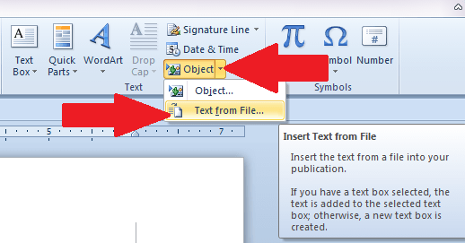
If you need admin support to finalize your proposal, please contact Lilyana Yankova at lyankova@aup.edu
Use the Text from File function under Insert/Object/Text from File to insert your files into this word document.

Description of the Modification Request
Describe the requested change in major/minor requirements (core courses, electives, credits)
…

Rationale for the Modification
Please explain the reason for the change
…

Are there changes needed to the assessment structure?
When changes are needed, please upload the amended assessment matrix.
☐ Yes |  | ☐ No
If yes, please describe the changes. If there are changes to the Learning Outcomes, please insert these here.
…
If no, please explain why there is no need to change
…
Any new courses – are there any new courses as part of this proposal?
If yes, please make sure to also submit a separate request for a new course
☐ Yes |  |  | ☐ No
Title in English | …
Title in French | …

Modifications to Course Titles – do you require modifications to any course titles?
If yes, please provide new title information in both English and French
☐ Yes |  | ☐ No
Title in English | …
Title in French | …

Modification to any Major, Minor or Program description for the Website
If the proposed modification requires a change to the program description on the website, please outline the required changes below
…

Modification to any Course Description
If there is a change to descriptions, please provide the revised description of the new major/minor, suitable for inclusion in the catalog
…

Impact on University Resources
Reminder, where new resources are needed, include a PDF of the ARC director, IT Director or University Librarian’s response email.
Does this proposal require new library resources? (library@aup.edu)
☐ Yes ☐ No
Does this proposal require any IT resources for this course? (helpdesk@aup.edu)
☐ Yes ☐ No
Does this proposal require any additional resources from ARC? (arc@aup.edu)
☐ Yes ☐ No
Does this proposal require other new resources?
☐ Yes ☐ No If yes, please elaborate below.

Use of Paris in our Curriculum
Does this curricular change impact or change the strategic pedagogical use of Paris or its environs in the program in question?
…

Impact on Current Student Population
Describe the effect that changes will have on current majors and minors, with a transition plan that includes a cutoff date that specifies when the new requirements will apply and which students will be affected by the change
…

Approvals
Graduate Program Director Approval, if applicable
Graduate Program Director’s Signature |  | Date
☐ Approved |  | ☐ Not Approved
Graduate Program Director’s Comments
Department Chair Approval
Department Chair’s Signature |  | Date
☐ Approved |  | ☐ Not Approved
Department Chair’s Comments
Curriculum Committee Approval
Curriculum Committee Chair’s Signature |  | Date
☐ Approved |  | ☐ Not Approved
Comments
Academic Affairs Approval
Associate Dean’s Signature | Date
☐ Approved | ☐ Not Approved
Comments

