CURRICULUM PROPOSAL FORM
SLIGHT CHANGES TO CURRICULUM (COURSE TITLES, PREREQS)

Title of Proposal: | …
Author of Proposal: | …
Author’s home department: | …

Required Supporting Documents
The following required* documents must be uploaded to the CC Sharepoint
Please name your document with your last name, type of proposal, title of proposal and document type (e.g. MARTZ Slight Change IDISC to HI Cover Sheet)
☐ *This cover sheet completed with all signatures and dates
☐ *Minutes of departmental meeting
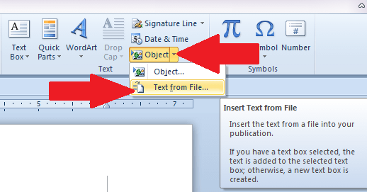
If you need admin support to finalize your proposal, please contact Lilyana Yankova at lyankova@aup.edu
Use the Text from File function under Insert/Object/Text from File to insert your files into this word document.

Description of the Change
Please indicate a clear change showing “From” and “To” and rationale for the change
…

Are there changes in course titles?
☐ Yes |  | ☐ No
If yes, please describe the changes.
…
Title in English | …
Title in French | …

Approvals
Graduate Program Director Approval, if applicable
Graduate Program Director’s Signature |  | Date
☐ Approved |  | ☐ Not Approved
Graduate Program Director’s Comments
Department Chair Approval
Department Chair’s Signature |  | Date
☐ Approved |  | ☐ Not Approved
Department Chair’s Comments
Curriculum Committee Approval
Curriculum Committee Chair’s Signature |  | Date
☐ Approved |  | ☐ Not Approved
Comments
Academic Affairs Approval
Associate Dean’s Signature | Date
☐ Approved | ☐ Not Approved
Comments

