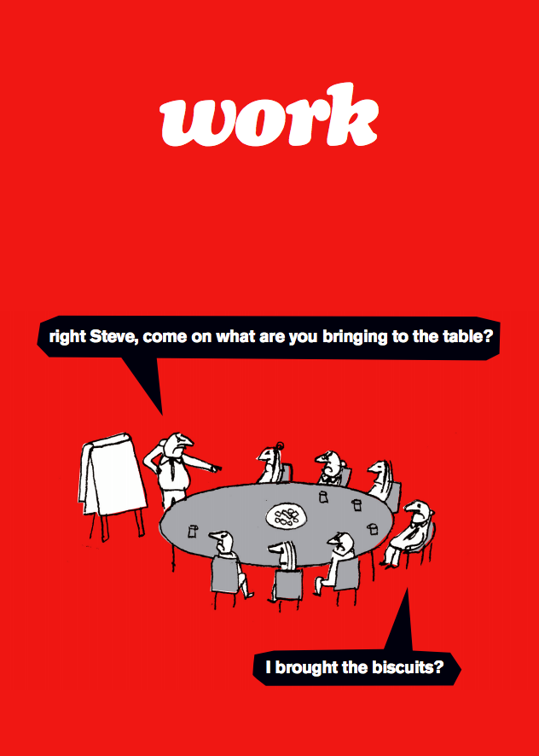

Welcome back!

Your friendly TLC

AUP Teaching and Learning Center, tlc@aup.edu
Rebekah Rast, rrast@aup.edu
Elena Berg, eberg@aup.edu
Russell Williams, rwilliams@aup.edu

Below is the schedule of upcoming TLC events
Digital Liberal Arts with David Wrisley from the American University of Beirut.
Thurs. March 16, 3:30-5 Presentation AND Fri. March 17, 11-2 Workshop (including lunch)
To read about David’s work, click here http://djwrisley.com/
Contact Rebekah rrast@aup.edu if you are interested in an individual meeting with David about digital projects.
Wed. Mar. 22, 5-6:30 pm (C-102) Mellon Pedagogical Seminars, Co-teaching at AUP Part II, facilitated by Elena Berg.
Wed. Apr. 12 (C-103) Two interactive-teaching workshops:
- Interactive language teaching (13h30-15h30), facilitated by Shona Whyte, University of Nice
- Interactive science teaching (16h00-18h00), facilitated by Eric Pallant, Allegheny College
Lunch conversations (12:15-1:15)
Fri. Mar. 10 (C-102) Grading group work, with Robert Earhardt
Wed. Mar. 22 (room TBA) theme TBA
Fri. Apr. 21 (C-102) theme TBA

