Outcomes Assessment Day 9th May, 2019, final report.

Dear Colleagues,
On May 9th 2019, we held our annual Outcomes Assessment Day (Table 1). After coffee and croissants, and a brief welcome from our provost, I gave a 20min. presentation on the future of assessment at AUP (annex 1). After the presentation, and an ensuing vibrant discussion, participants had a choice of four 90min. workshops: “How do we assess digital Literacy”, “Start at the beginning: Defining & Assessing Mission Statements”, “Building an AUP Rubric Blueprint”, and “Streamlining assessment”. You will find a brief description of each workshop in annex 2. In keeping with the maxim “if there is no report, there was no meeting”, which you all adhere to, I am circulating the notes from the workshop leaders. If there is anything you want to add to these notes, do email me. I will add your comments to this report which will inform the Annual Institutional Assessment report drafted by myself and due in fall 2019.
Sincerely
Claudio Piani
Associate Dean for Educational Assessment

9:00 | Welcome and coffee
9:15 | Welcome from the Provost
9:30 | Presentation from the Ass. Dean of Assessment  Title: Future of Assessment at AUP
10:00 | Workshops
10:30
11:00
11:30 | Coffee and Icecream
12:00 | Panel of Rapporteurs
12:30 | Closing remarks
  - Table 1. Schedule for Outcomes Assessment Day

Notes from workshop: “Digital Literacy Assessment”
  - Run by Michael Stoepel
The Digital Literacy Assessment workshop’s aim was three-fold. First, the aim was to continue the conversation about digital literacy at AUP that the TLC (Teaching and Learning Center) had started during the last Faculty retreat in February. Secondly, given the fact, that the new GLACC includes digital literacy as one of the learning objectives and given the fact that the General Education committee will look at the implementation of digital literacy into the curriculum as of Fall 2019, the workshop shared language around the concept of digital literacy. Finally, the workshop shared examples of rubrics in order to evaluate students’ digital projects.
Below is a list of ideas that were shared during the workshop discussion:
· Suggestion to use the term “digital competencies” instead of “digital literacy”
· The language of the Digital Literacy learning outcomes is too “easy”. The language should reflect a university level.
· Digital literacy assignments should be intellectually stimulating and sophisticated (levels of complexity)
· The term “digital literacy” should not lead to a simplification (i.e. sometimes a research paper might be more sophisticated than a “web exhibit”)
· The term “digital literacy” should not lead to reduced complexity (such as putting ‘Digital literacy’ and ‘Communication Sciences’ together) – see the GLACC rational
· Discussion on learning specific digital tools vs learning “digital concepts” in the context of academic disciplines/majors
· It seems that to achieve “digital literacy” objectives, faculty need to collaborate with other colleagues as different expertise come together – digital data analysis and disciplinary knowledge
· From ‘digital visitor’ to ‘digital resident’ – a digital resident in the digital realm is/should be digitally literate in order to take on civic, economic and personal responsibilities
· Students need digital challenges and need to get confident to use digital tools even if they don’t master them (and there is no need to focus exclusively on tools but explain what is an algorithm, what are advantages and disadvantages of such technologies)
· There should be a minimum understanding of what we need to teach our students for the world they’re evolving in.

Notes from workshop: “Start at the beginning: Defining & Assessing Mission Statements”
Run by Darcee Caron and Sarah Bentley

We have produced a document (annex 3) that will assist faculty and staff as a tool to:
- Create/update/reaffirm their unit/academic department mission statements, and
- Deliver the requisite mission statement alignment matrix requested by our friends at Middle States.

The workshop discussion (with Danielle Savage, Elizabeth Guinel, and Celeste), raised the following questions.

Who should have a mission statement? Every department/unit that provides an assessment report. This includes:
- All academic departments
o Each graduate program, instead of being embedded in department missions?
- All administrative units, however, some are grouped at a higher level.
o Student development includes student leadership, athletics, health, SIS, housing, security, and cultural programs.
o Academic Affairs submits for the provost’s office However, the following units (that fall under Academic Affairs) submit separately:
- Academic Advising
- Internship and Career Advising
- SAS
- Registrar
- GPS

Notes from workshop: “Building an AUP Rubric Blueprint”
Run by Carla Canelas Tobar and Hannah Westley
The workshop on rubrics explained the utility of investing in rubrics for grading coursework and how these can aid assessment at all levels. We looked at examples from other institutions to decide which might be most relevant to AUP.
Starting with rubrics for essays, portfolios and other capstone projects, we thought about how rubrics could be developed to assess how well individual assignments served the course learning outcomes and how, using an assessment alignment matrix, these results could then be aligned with the Major's Learning Outcomes, and ultimately with the institution's learning outcomes.
Certain profs present expressed their reluctance to invest in rubrics because of the time it takes to develop them. Another prof explained that whenever she marked with rubrics, it took her a lot longer than it would without. A dept chair argued that we should develop rubric software to grade with, from which data could then be collated for dept assessment reports.
The advantages of grading with rubrics were clear for all. They make for greater objectivity, transparency in grading, clarity of expectations and aid in closing the assessment loop. Nevertheless, there is a continued resistance to using them that stems partly from the time investment required and partly from a fear that it might lead to a 'shallow standardization' of learning objectives.

Notes from Workshop: “Streamlining the assessment process”
  - Run by Claudio Piani and Kevin Fore
- Consider assessing major learning outcomes and unit long-term objectives on a two year cycle. For each learning outcome, a year of assessment would be followed by a year of implementation of planned actions based on assessment.
- Essays, portfolios, projects, reports, and suchlike, should all be graded following rubrics available through the syllabi. Consider aligning all rubrics with course LOs.
- Tests, quizzes, and suchlike should be associated to a “blueprint”, i.e. a mapping from test questions to course LOs. Blueprints are to quizzes and tests what alignment matrixes are to rubrics.
- Consider modifying Learning Outcomes of courses that constitute the cores of majors so that they have at least two of the LOs of the major.
- Assessment of Administrative units could be streamlined by following a bottom-up approach with sub-departments contributing self-assessment to the departments in a pyramid structure.
- AUP should expand the use of annual student evaluations for administrative departments.
- Conclusions based on assessment, third column on the assessment matrixes, should be arrived at through a consensus process, ideally during a departmental meeting.
- Effective, streamlined assessment requires information flow from both the bottom up and the top down. Share regular reports with all constituents demonstrating how assessment is used at the leadership level for policy and budget decisions.

Annex 1: Presentation: “Future of assessment at AUP”
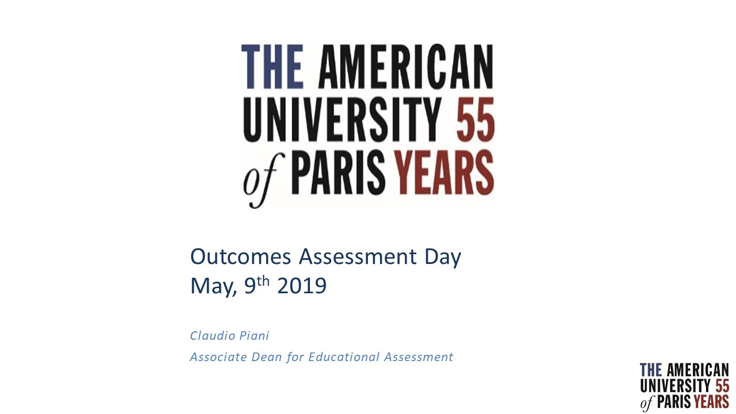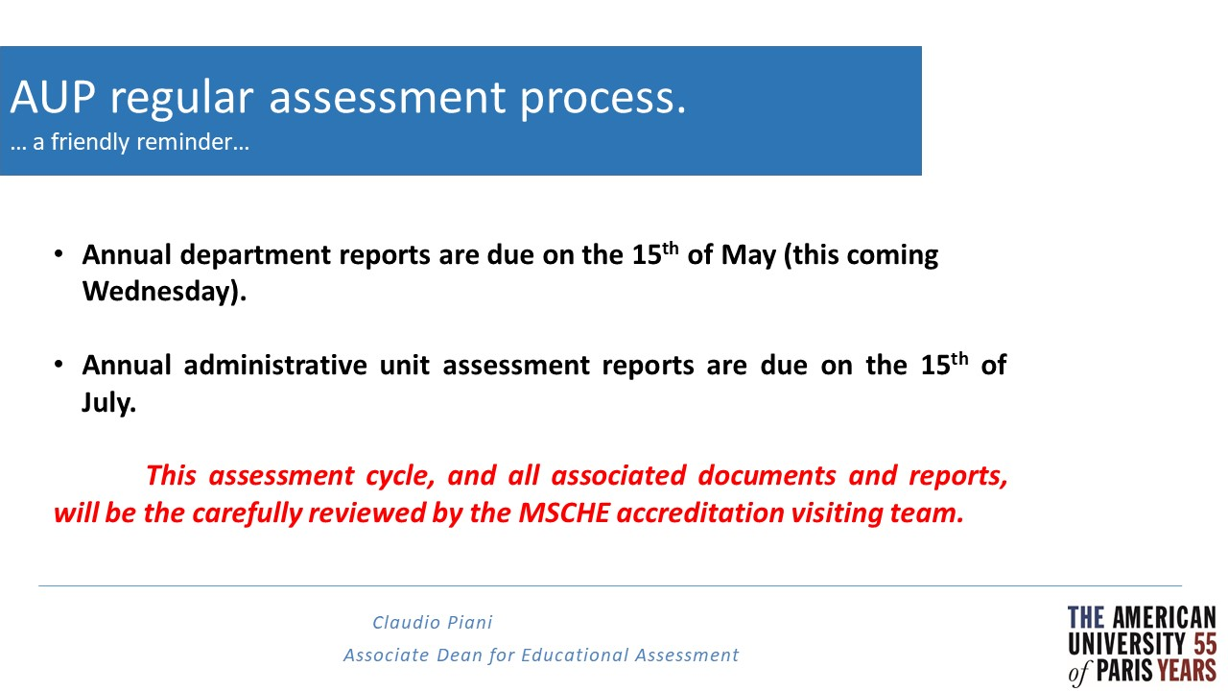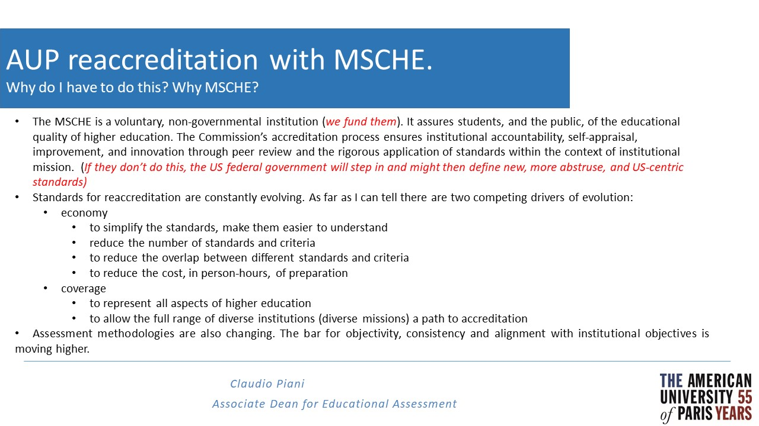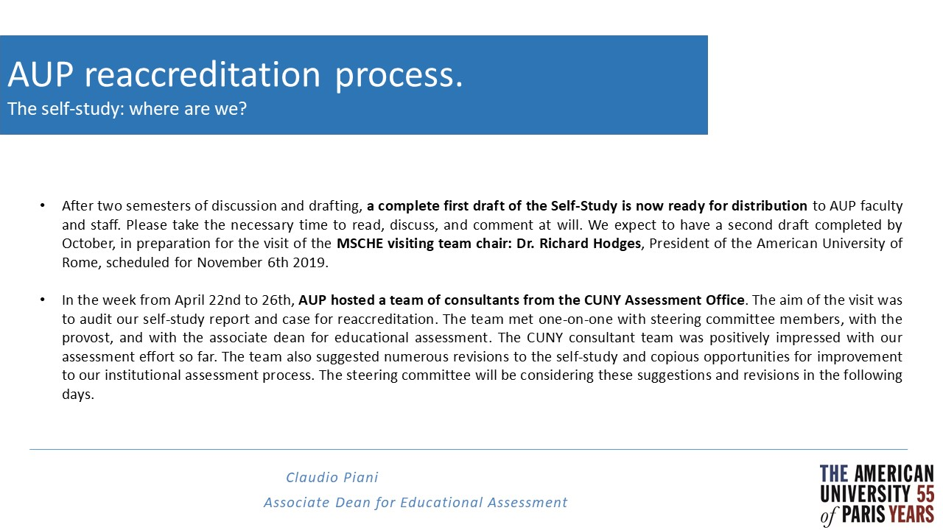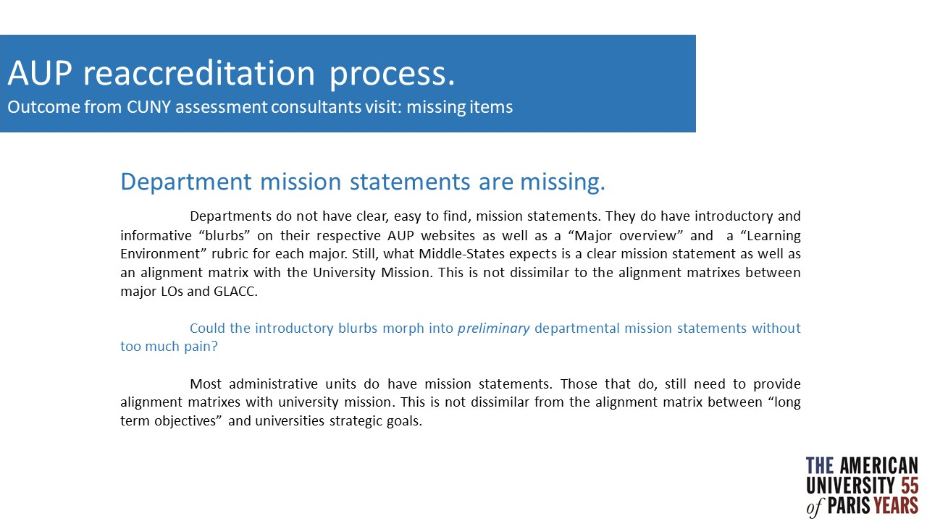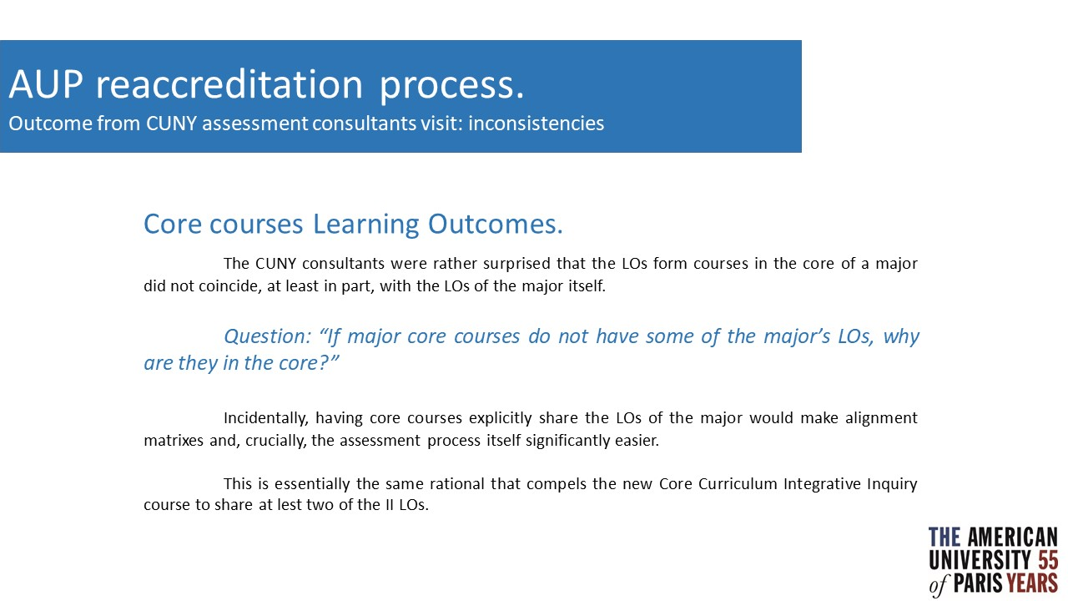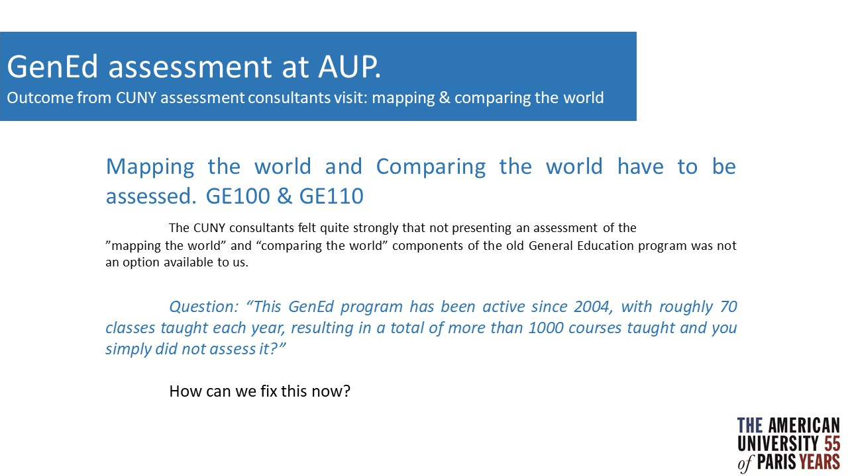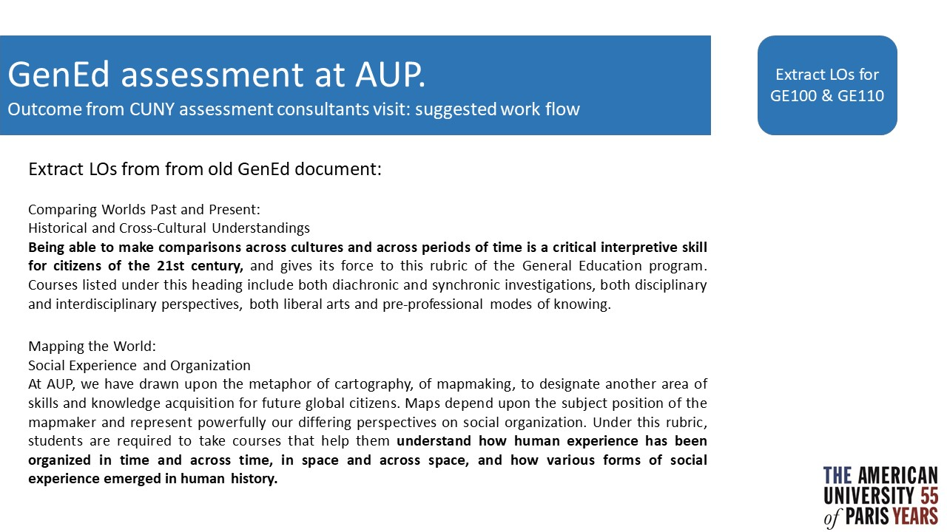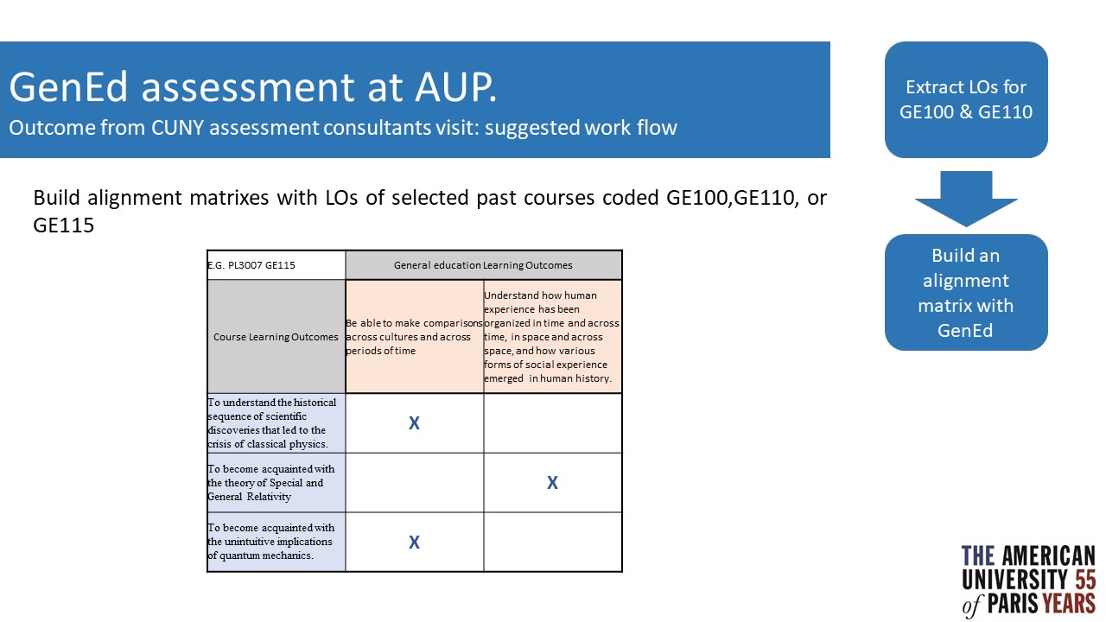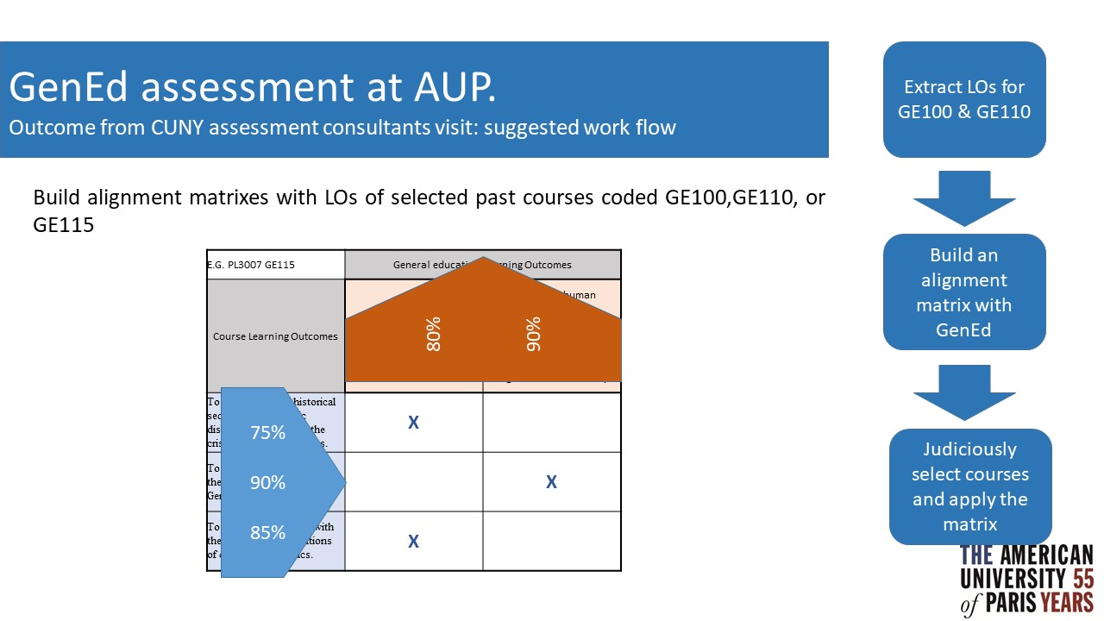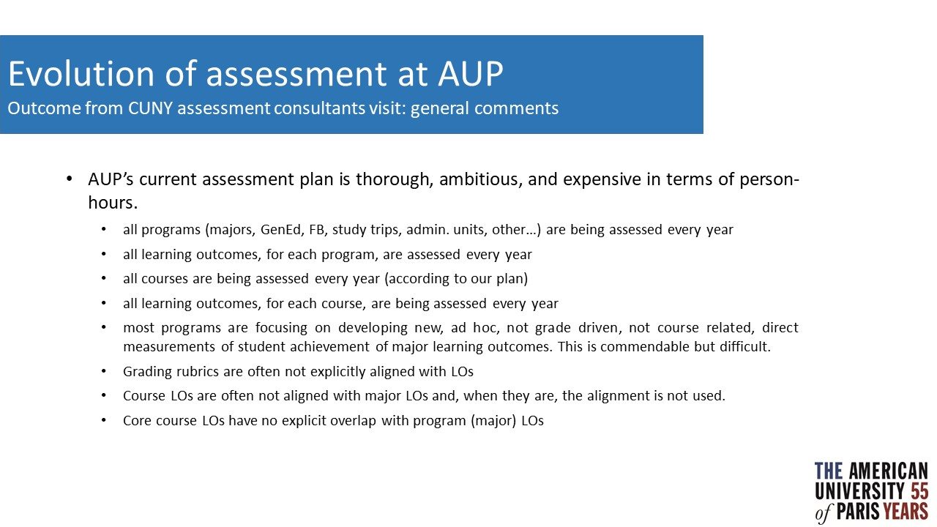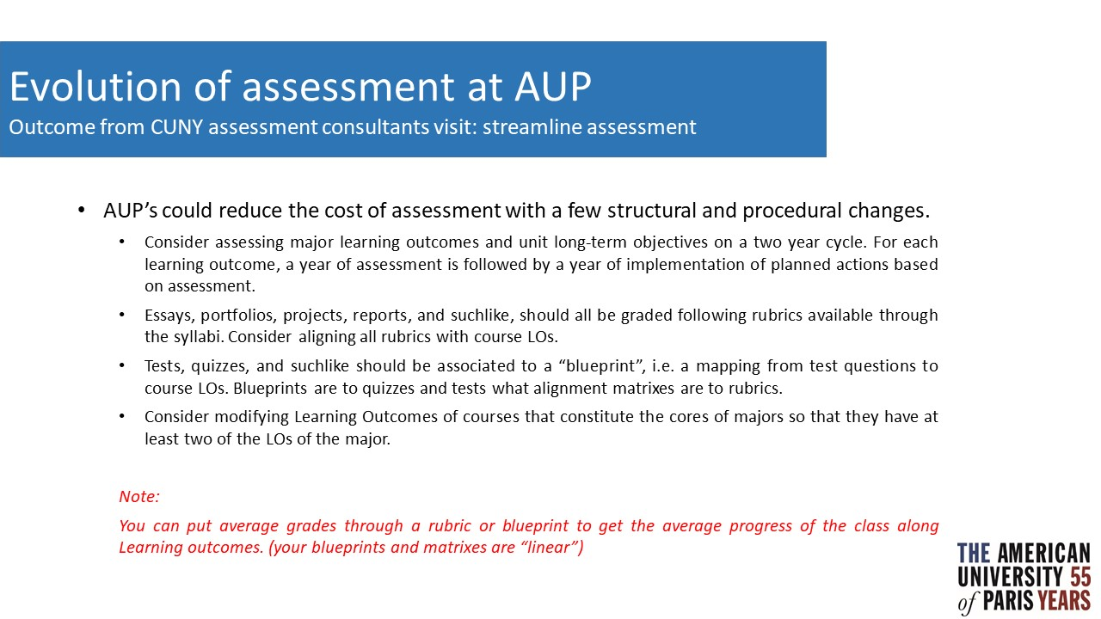

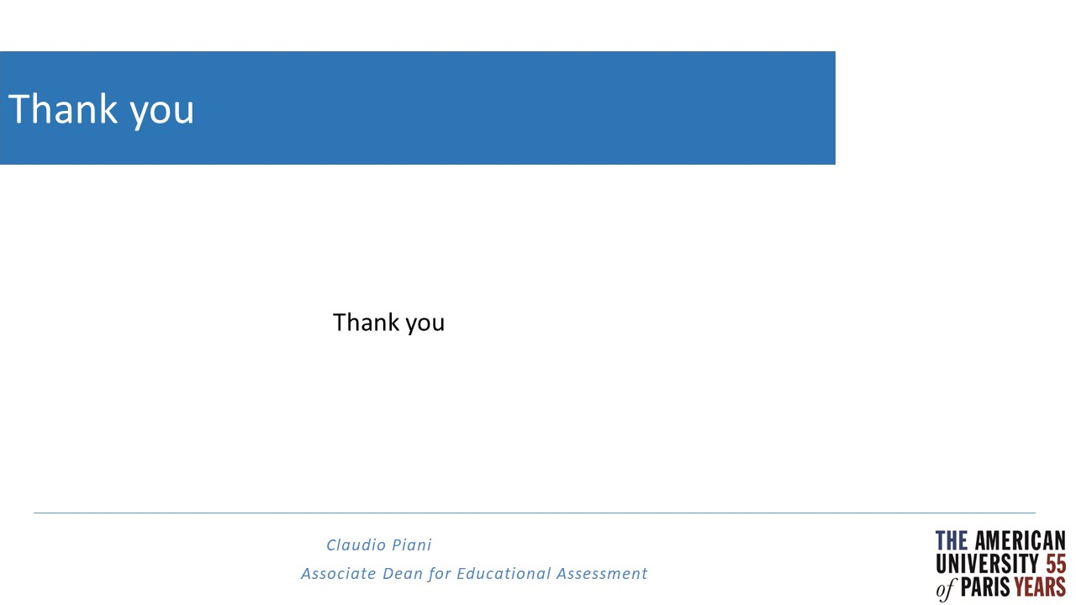

Annex 2: Workshop descriptions
- How do we assess Digital Literacy?
Run by Michael Stoepel
Digital Literacy is one of the new elements of the GLACC. The workshop's objective is to continue the conversation on digital literacy that the Teaching and Learning Center started at the last faculty retreat in February. The focus of the workshop is two folded: what do we mean when we say a student is digital literate and collect ideas on how to assess digital literacy. Best practice examples of digital literacy assessment from other institutions will be shared as well.
- Start at the beginning: Defining & Assessing Mission Statements
Run by Darcee Caron and Sarah Bentley
In the spirit of this year’s AUP Assessment Day theme “Assessing Assessment”, this workshop will focus on the foundation of all assessment activities: mission statements. Mission statements are broad statements of the purpose and values of the institution, the administrative unit, or the academic department. Since all assessment activities, at each level, should flow from the mission, periodic assessment/update/reaffirmation of mission statements is an important part of evaluating our assessment processes. In this workshop, we will consider a rubric for evaluating mission statements, examine various AUP administrative unit and academic department mission statements in light of the rubric, and consider how various AUP mission statements align with AUP’s institutional mission. The goal of the workshop is to contribute to the creation of an updated assessment handbook.
- Building an AUP Rubric Blueprint
Run by Carla Canelas Tobar and Hannah Westley
Grading is among the most significant tasks we undertake as teachers. A rubric can facilitate the process by providing a way to grade fairly, to give feedback easily, and to asses assignments consistently from student-to-student. A rubric describes the criteria that will be used to evaluate a specific task. It allows instructors to communicate expectations to students (the student knows what is expected of him or her and how he or she will be graded) and students to check in on their progress. In fact, research suggest that when rubrics are included with an assignment, students tend to use them (Andrade, H.G., 2005; Reddy and Andrade, 2010). The aim of this workshop is to develop a set of general principles that will make the grading process as fair and efficient as possible. The outcome will be a flexible rubric available to any and all AUP instructors who desire to use it.
- Streamlining assessment
Run by Claudio Piani and Kevin Fore
In preparation for AUP’s 2020 Middle-States reaccreditation application, a team of assessment consultants from the CUNY was on campus for the last week of April. One of the most important findings was that AUP’s assessment plan is ambitious but lacks is the standard automation and streamlining processes that other, perhaps larger, universities have. In this workshop, we will look at how other universities reduce and automate their assessment workload. We will select and propose structures and processes that can be implemented in AUP along with timelines for implementation. Results from this workshop will inform the self-study.

Bibliography:
Andrade, H.G. (2005). Teaching with rubrics: The good, the bad, and the ugly. College Teaching, 53(1), 27-30
Reddy, Y. M., & Andrade, H. (2010). A review of rubric use in higher education. Assessment & Evaluation in Higher Education, 35(4), 435-448.

Annex 3: Drafting Mission Statements to Serve Assessment Needs
The following Unit Mission Rubric may assist in creating administrative unit mission statements.

 | Criteria | Meets Criteria When
Each administrative unit mission statement should include the following information.
1 | Description | Description and constituencies served.
2 | Purpose & specificity | Purpose of the unit is clearly stated; include attributes that separate the unit from other units; the mission will not be applicable to another unit if the name of the unit is removed.
3 | Operations and services | The most important services of the unit and how the unit contributes to the experiences &/or education of students.
4 | Aspirations & outcomes | Long term goals; these may include increased efficiency, reduced cost…

The following Unit Mission Rubric may assist in creating academic department mission statements.

 | Criteria | Meets Criteria When
Each academic department mission statement should include the following information.
1 | Description | Description of the department & constituencies served
2 | Purpose & specificity | Intellectual outcomes; in addition to student learning experience these may include faculty research, administrative service, & academic partnerships. Articulate the dept’s niche within the global field. The mission will not be applicable to another dept if the name of dept is removed.
3 | Learning experiences specific to the department | The most important services of the dept; these may include teamwork, lecture classes, mentoring, opportunities for applied knowledge
4 | Aspirations & outcomes | Long term goals; these may include jobs students may look for after graduation, departmental reputation in the field, etc.

All mission statements should be evaluated for…
Clarity & Conciseness: Mission is clear and conveys the intended purpose; no excessive wordiness.
Alignment: Department mission is aligned with AUP institutional mission using the alignment matrix.

Alignment of Unit Mission the AUP Institutional Mission

 | AUP Mission Statement | Code
Description & constituents; general purpose | Chartered as a liberal arts college in 1962, The American University of Paris is today an urban, independent, international university located at the meeting point of France, Europe, and the world. The University provides a student-centered, career-enabling, and transformative learning experience to the global explorers who are its Bachelor’s and Master’s students, empowering them to cross both disciplinary and cultural borders with ease in order to assume their places as responsible actors and leaders in over 140 countries worldwide. | AUP  MS_1
Specific purpose; student learning outcomes at AUP | AUP’s mission is to educate its graduates to communicate effectively in a world of many languages; to read well, listen carefully, and write intelligently in a voice of their own; to become critical thinkers about history and human societies, economics, culture, literature, the arts, science, politics, psychology, business, and communication; to develop creative interdisciplinary solutions to contemporary global challenges; to be digitally literate in a world of swift-paced change; to understand the ethical imperatives of living in such a world; and to move across contemporary cultural borders with a sense of commitment to and responsibility for a world held in common. | AUP  MS_2
Services, learning environment, specificity | The University achieves its mission by providing its students with a curriculum combining liberal arts inquiry, preparation for professional life, and student-centered, active learning in small classroom settings; dynamic, engaged teaching informed by both disciplinary and interdisciplinary faculty scholarship; a host of opportunities for direct experience of the world and its many cultures; a wealth of intellectual exchanges on campus at conferences of global reach; and an integrated learning model that marries classroom learning and its application to real-world contexts, preparing students to master and to make, to reflect and to apply, to analyze and to act. | AUP  MS_3
Aspirational outcomes and post-graduate outcomes | In these ways, an AUP education supports professional skills development and cultural fluency—the sense of global engagement and the capacity to negotiate difference that emerge from the natural diversity of AUP’s student and faculty bodies. Upon graduation, AUP students take part in and benefit from the global network that is our worldwide alumni community, creating lifelong connections to one another and to the University. | AUP  MS_4

Sample Mission Statement Alignment Matrix

Unit Mission Statements | AUP  MS_1 | AUP  MS_2 | AUP  MS_3 | AUP  MS_4
The primary mission of the Center for Internship and Career Advising is student-focused: to contribute to AUP students’ successful transition to professional life by providing comprehensive career development resources. This comprises the facilitation of (1) student’s self-assessment and identification of career objectives, (2) of professional opportunities (such as internships, and full-time employment), (3) graduate school exploration and applications. |  | x | x | x
Complementary to this student-centered mission are two additional pillars: (1) ongoing work to sustain strong relationships with AUP’s existing employer network, paired with targeted efforts to cultivate new relationships, |  | x |  | x
and (2) ongoing transversal collaboration within and across the institution on projects and initiatives that support student success, institutional reputation, and alumni relations. |  |  | x | x

