The Carte Vitale
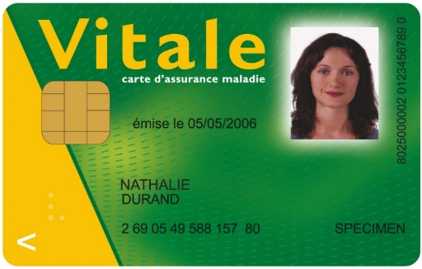
The Carte Vitale simplifies transactions and means that you do not have to send off paper forms to claim reimbursement. Simply produce the card every time you need healthcare, ensuring faster reimbursement. The issuing of your medical card will be taken care of by your Mutuelle.

To apply for a carte vitale, foreigner students must provide the following documents:
- Original of Birth Certificate
- Certified translation of your birth certificate (ask the Health Office for the list of certified translators available in Paris)
- Apostille (contact your embassy/consulate for that)
- Copy of a valid visa
- Copy of your passport
- Copy of your attestation de droit
French students must provide a birth certificate and a copy of the ID card.
Once the documents are sent, you will then be sent the relevant forms by post, which you must fill in and send back with an identity photo and a copy of your identity card (or passport).
You should expect to wait at least a month for your card, which will then be sent to the address that you have requested.
This card is not a means of payment. It allows your local student Mutuelle to deal with your claims more speedily and reimburse any outlay within 48h.

The Carte Vitale
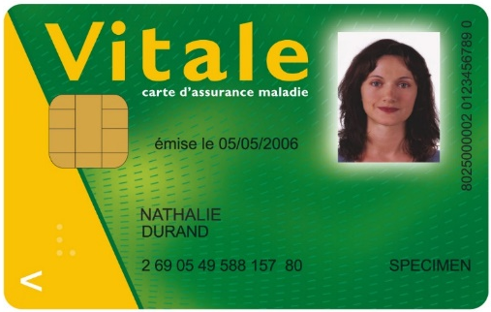
The Carte Vitale simplifies transactions and means that you do not have to send off paper forms to claim reimbursement. Simply produce the card every time you need healthcare, ensuring faster reimbursement. The issuing of your medical card will be taken care of by your Mutuelle.

To apply for a carte vitale, foreigner students must provide the following documents:
- Original of Birth Certificate
- Certified translation of your birth certificate (ask the Health Office for the list of certified translators available in Paris)
- Apostille (contact your embassy/consulate for that)
- Copy of a valid visa
- Copy of your passport
- Copy of your attestation de droit
French students must provide a birth certificate and a copy of the ID card.
Once the documents are sent, you will then be sent the relevant forms by post, which you must fill in and send back with an identity photo and a copy of your identity card (or passport).
You should expect to wait at least a month for your card, which will then be sent to the address that you have requested.
This card is not a means of payment. It allows your local student Mutuelle to deal with your claims more speedily and reimburse any outlay within 48h.

